Homework 2

Yixin Yin

Problem 1

My Answer:

a.

I use matlab to get the final answer. I write a small function to get the results. Here is the code: (the input is a string and the output is a struct (lastcol,index))

function [ output ] = bwt( input )

%UNTITLED Summary of this function goes here

% Detailed explanation goes here

original = input

A = [input];

B = [];

for i = 1:length(input) - 1

input = [input(2:end),input(1)];%calculate A(the rotation matrix)%

A = [A;input];

end

B = sortrows(A);%get B matrix use sortrows%

for i = 1:size(B,1)%get the rows of B, sieze(Matrix) we get the (rows, cols), then index 1 means the rows%

if original == B(i,:)%find the index L%

index = i - 1;%the index begins at 1 in matlab!!!!!%

break;

end

end

lastcol = B(:,size(B,2))

ret.lastcol = lastcol';

ret.index = index;

output = ret;

disp(B)

%output = {lastcol',index};%

end

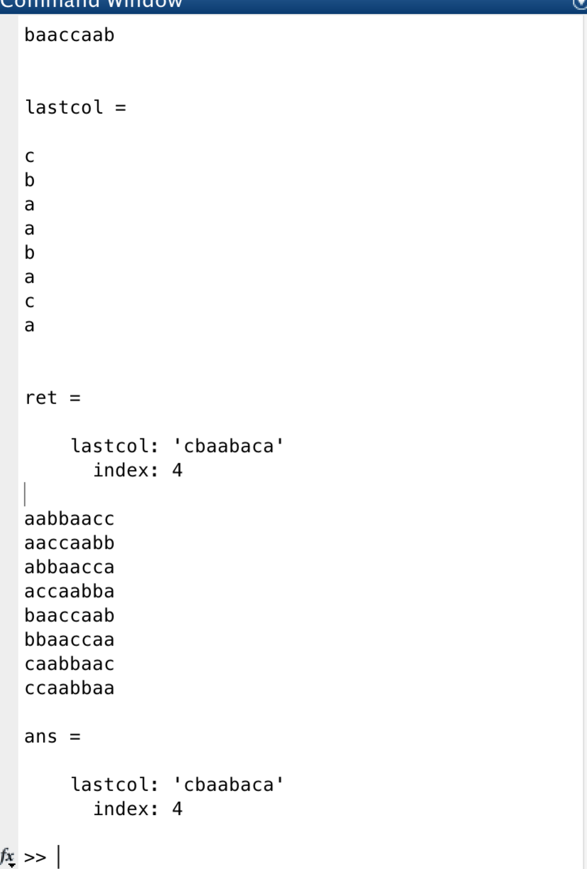

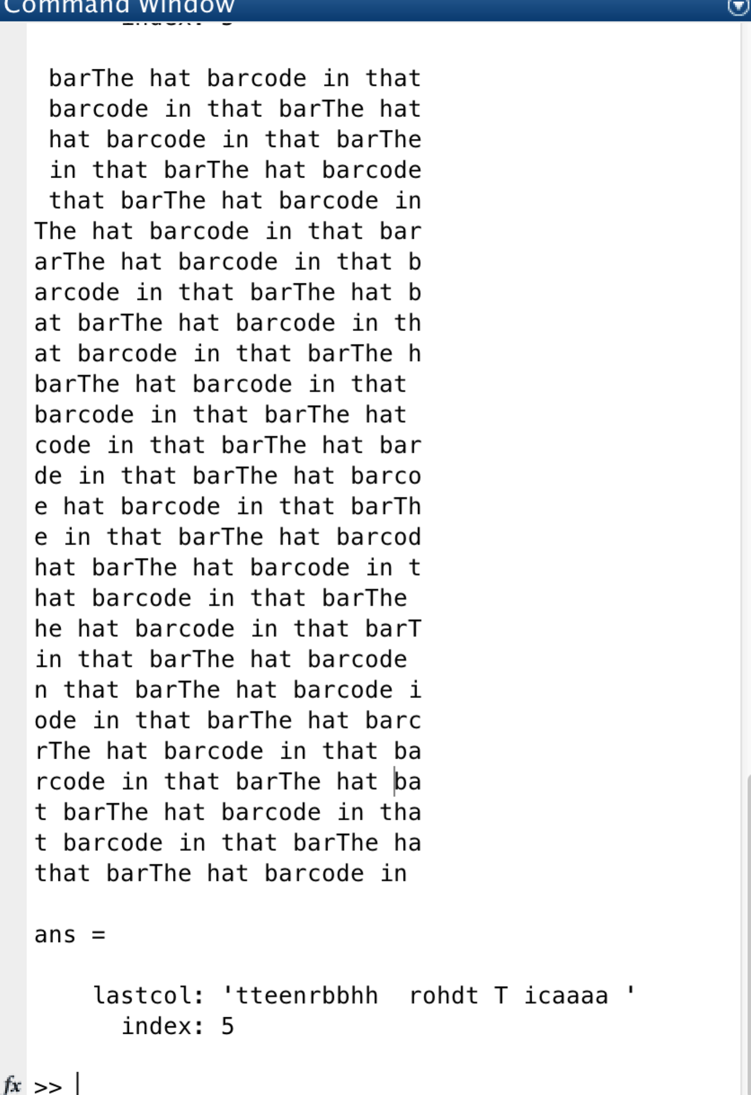

so the answer is (“cbaabaca”,4), and (‘'tteenrbbhh rohdt T icaaaa '’,5)

b. algorithm to constructs B from (y,L)

My answer:

we just need the lastcolumn y to construct B, we call the algorithm INVBWT

The input is the output of question 1.a, I ‘ll use the example of “baaccaab”

The input is ‘cbaabaca’

1. First we put the input into a column so it looks like:  
   (c,b,a,a,b,a,c,a)’ , then we sort the column and we get ‘a,a,a,a,b,b,c,c’,we call

It C

1. We insert the input into C before each element. We get ‘’ca,ba,aa,aa,bb,ab,cc,ac” and then we sort it and we get “aa,aa,ab,ac,ba,bb,ca,cc” we call it C
2. we repeat 2 until the length of each line equals to the input and we stop.
3. Then we get the Matrix B
4. I ‘ll give the whole example in question 1.d

c.

My Answer:

Since we have reconstruct the matrix B in question 1.c, and we also notice that L is the location of original x in B

So we just need to get the L th row in B and we get the original x.(notice that we the index of first row is 0(not 1) in this algorithm)

The code:

function [ output ] = INVBWT( input )

%input is like input.lastcol = 'cbaabaca' input.index = 4%

last = input.lastcol';

index = input.index;

B = [];

for i = 1:length(input.lastcol)

B = [last,B]

B = sortrows(B);

end

output = B(index+1,:)

end

ScreenShot:

First define input as struct

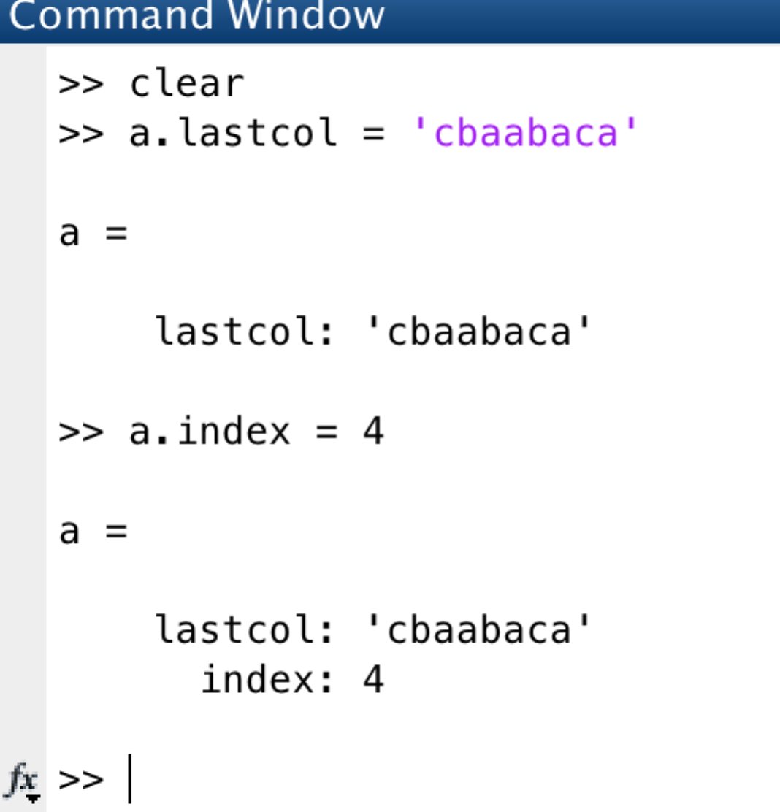

then call the function and we get :

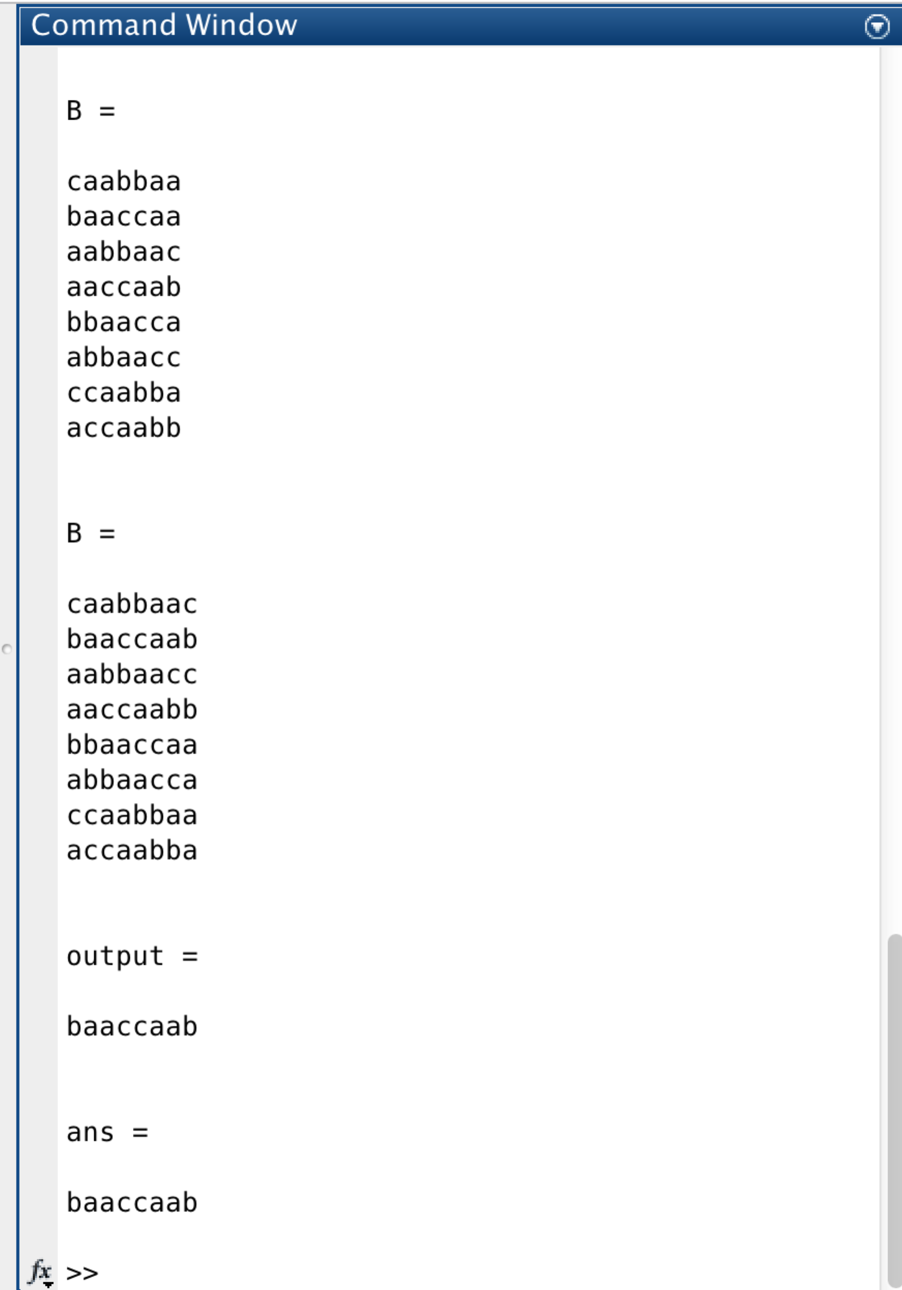

d.

My Answer:

Input (‘cbaabaca’,4)

1. first we have (c,b,a,a,b,a,c,a), then we sort it and get (a,a,a,a,b,b,c,c) called C
2. insert the input into each element of C and we get ((ca,ba,aa,aa,bb,ab,cc,ac)) and we sort it and get (aa,aa,ab,ac,ba,bb,ca,cc) called C
3. repeat again and again:

(caa,baa,aab,aac,bba,abb,cca,acc) sort

(aab,aac,abb,acc,baa,bba,caa,cca)

(caab,baac,aabb,aacc,bbaa,abba,ccaa,acca)sort (aabb,aacc,abba,acca,baac,bbaa,caab,ccaa)

(caabb,baacc,aabba,aacca,bbaac,abbaa,ccaab,accaa) sort

(aabba,aacca,abbaa,accaa,baacc,bbaac,caabb,ccaab)

(caabba,baacca,aabbaa,aaccaa,bbaacc,abbaac,ccaabb,accaab) sort

(aabbaa,aaccaa,abbaac,accaab,baacca,bbaacc,baabba,ccaabb)

(caabbaa,baaccaa,aabbaac,aaccaab,bbaacca,abbaacc,cbaabba,accaabb)sort

(aabbaac,aaccaab,abbaacc,accaabb,baaccaa,bbaacca,caabbaa,ccaabba)

(caabbaac,baaccaab,aabbaacc,aaccaabb,bbaaccaa,abbaacca,ccaabbaa,accaabba) sort

(aabbaacc,aaccaabb,abbaacca,accaabba,baaccaab,bbaaccaa,caabbaac,ccaabbaa)

because L = 4, so we get x = baaccaab

Problem 2

a.

My Answer:  
Here is my code for the whole question:

clear

k = [0:1:31]

xk = (k.^2 + 1)/2

yk = sin((5\*k+1)\*pi/32)

X = fft(xk')

Y = fft(yk')

MX = abs(X)

MY = abs(Y)

TRY1 = sortrows(X)

TRY2 = sortrows(Y)

MX17 = TRY1(1:17)

MY17 = TRY2(1:17)

XX = X

YY = Y

for i = 1:length(XX)

if(ismember(XX(i),MX17))

XX(i) = 0

end

end

for i = 1:length(YY)

if(ismember(YY(i),MY17))

YY(i) = 0

end

end

xx = ifft(XX)

yy = ifft(YY)

plot(k,xk,'r',k,xx,'b')

legend('xk','xx')

plot(k,yk,'r',k,yy,'b')

legend('yk','yy')

X IS 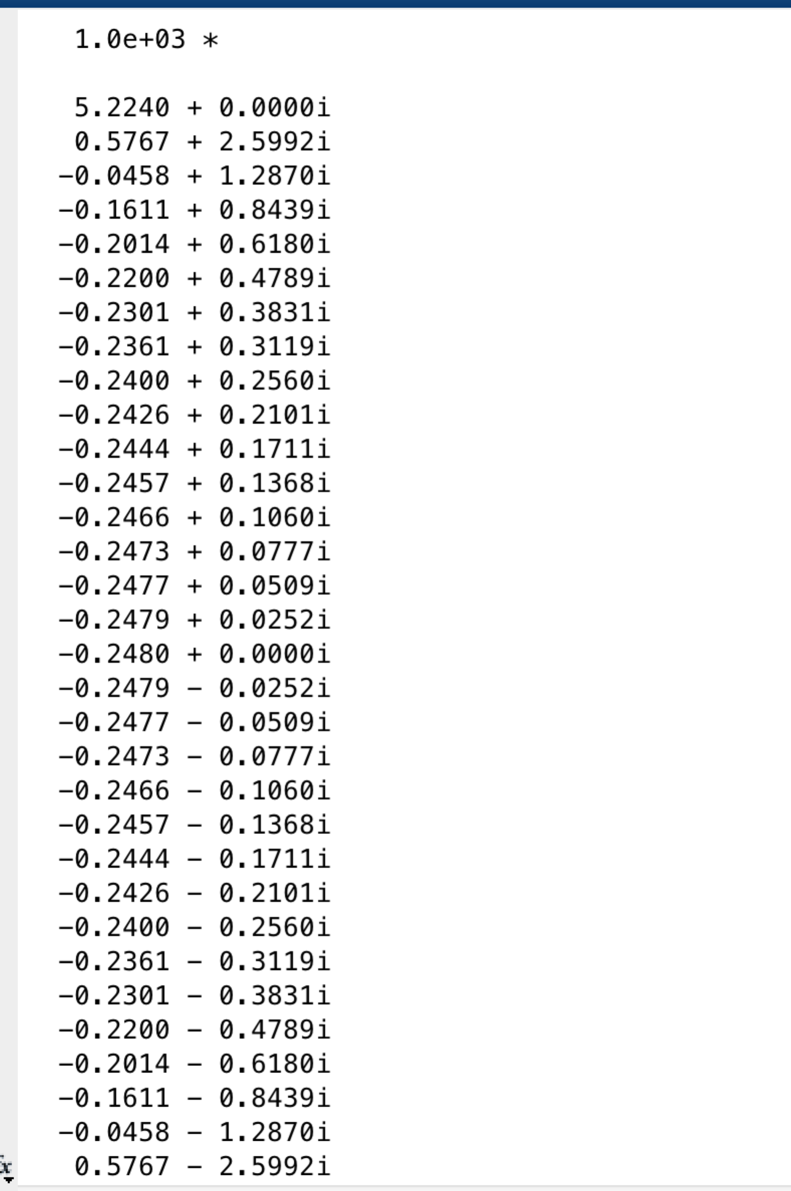

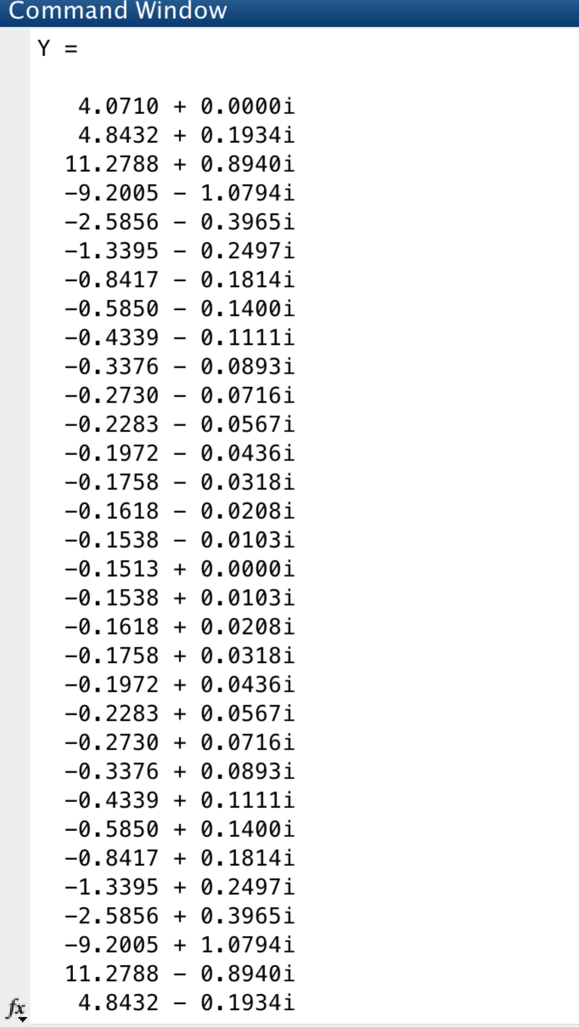

b.

the magnitude of X is

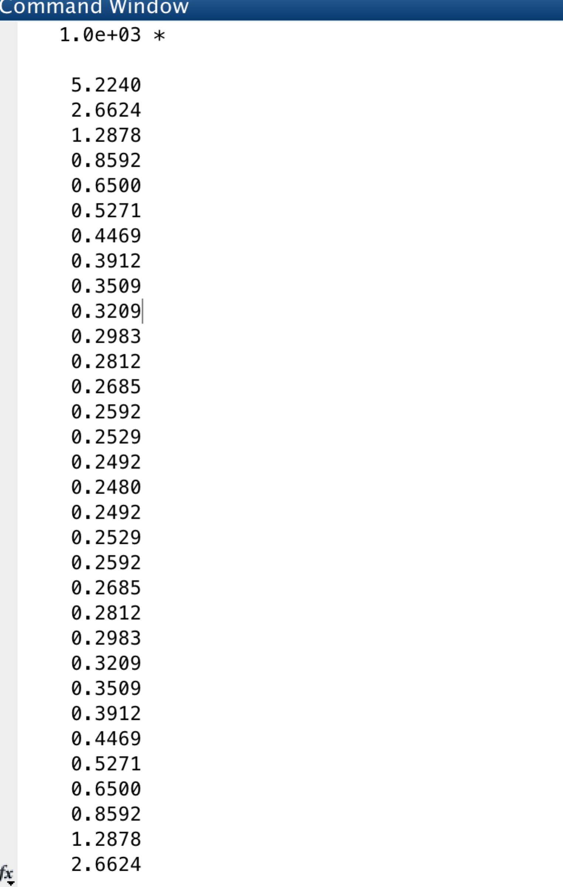

the magnitude of Y is

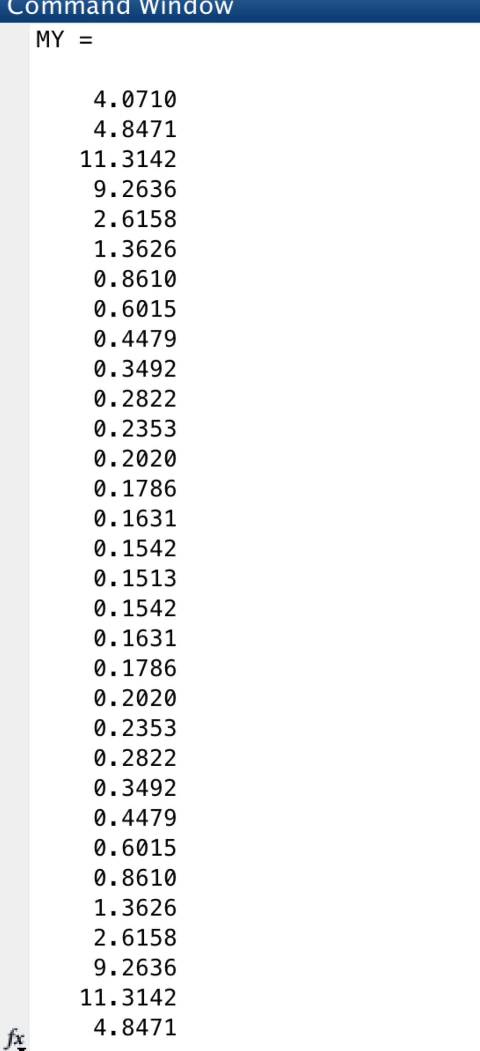

c.

In matlab, if an array contains complexity number, when you sort the array, it will sort by their magnitude

17 smallest magnitude elements of in X are:

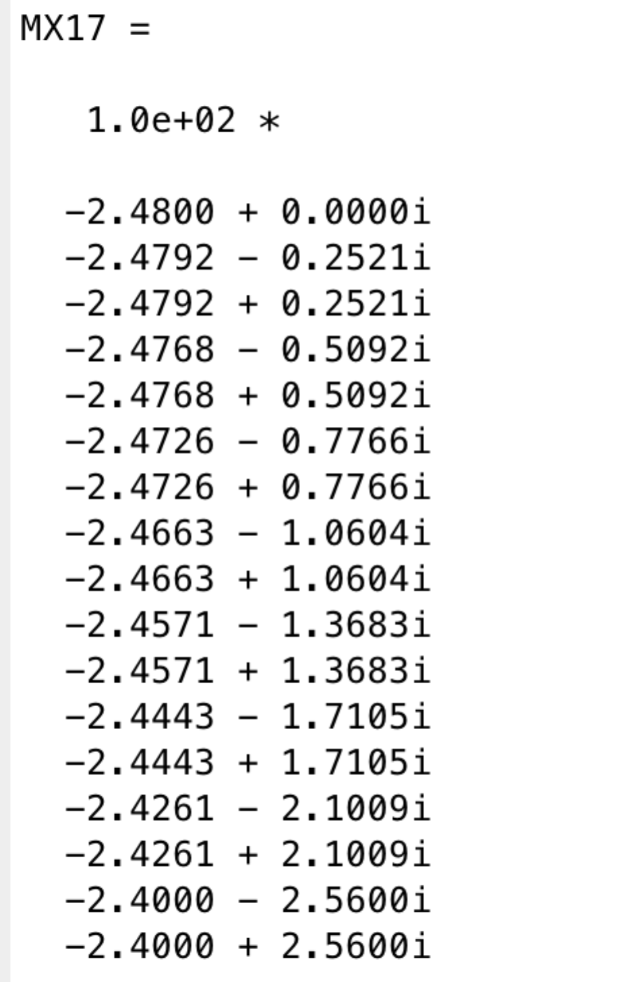

17 smallest Y are:  
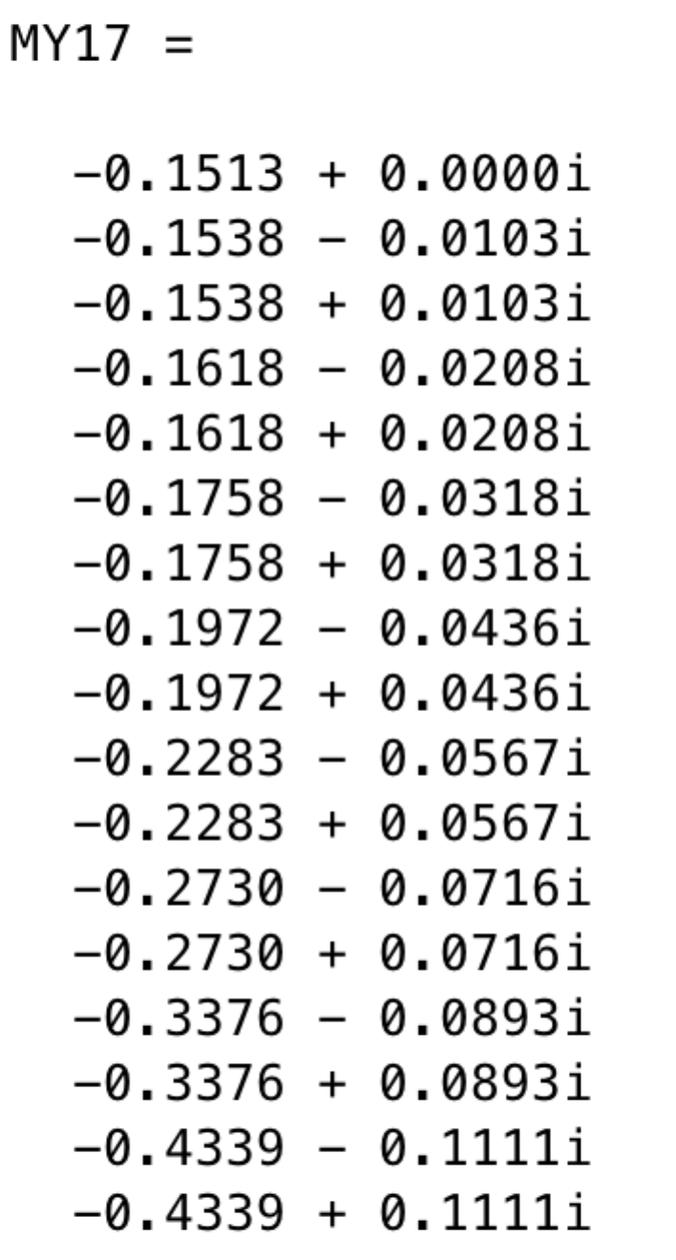

d.

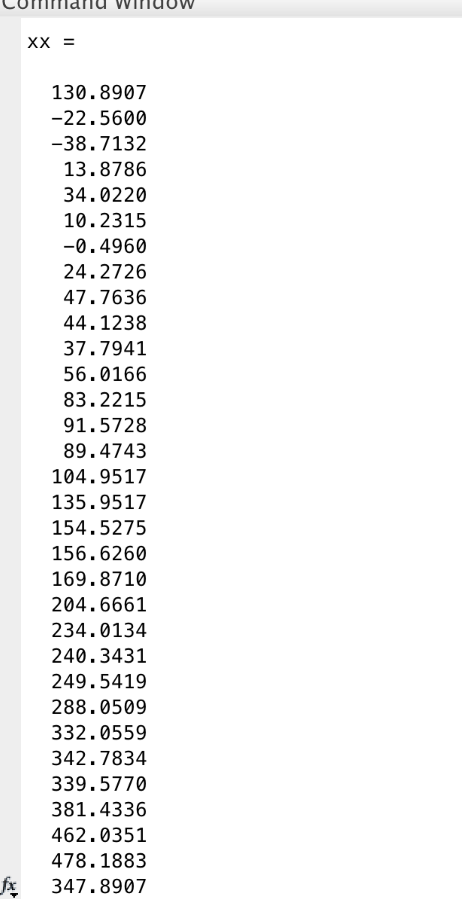

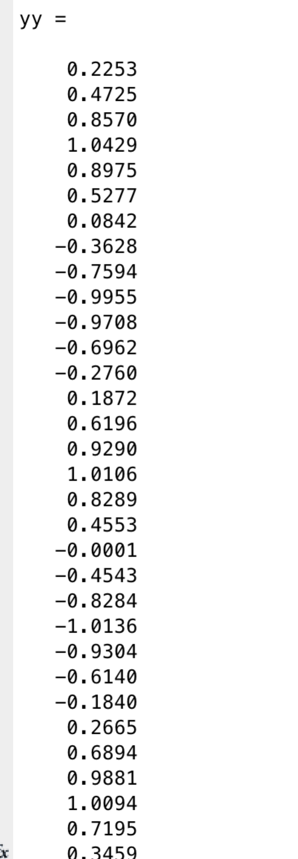

e.

xk and xx

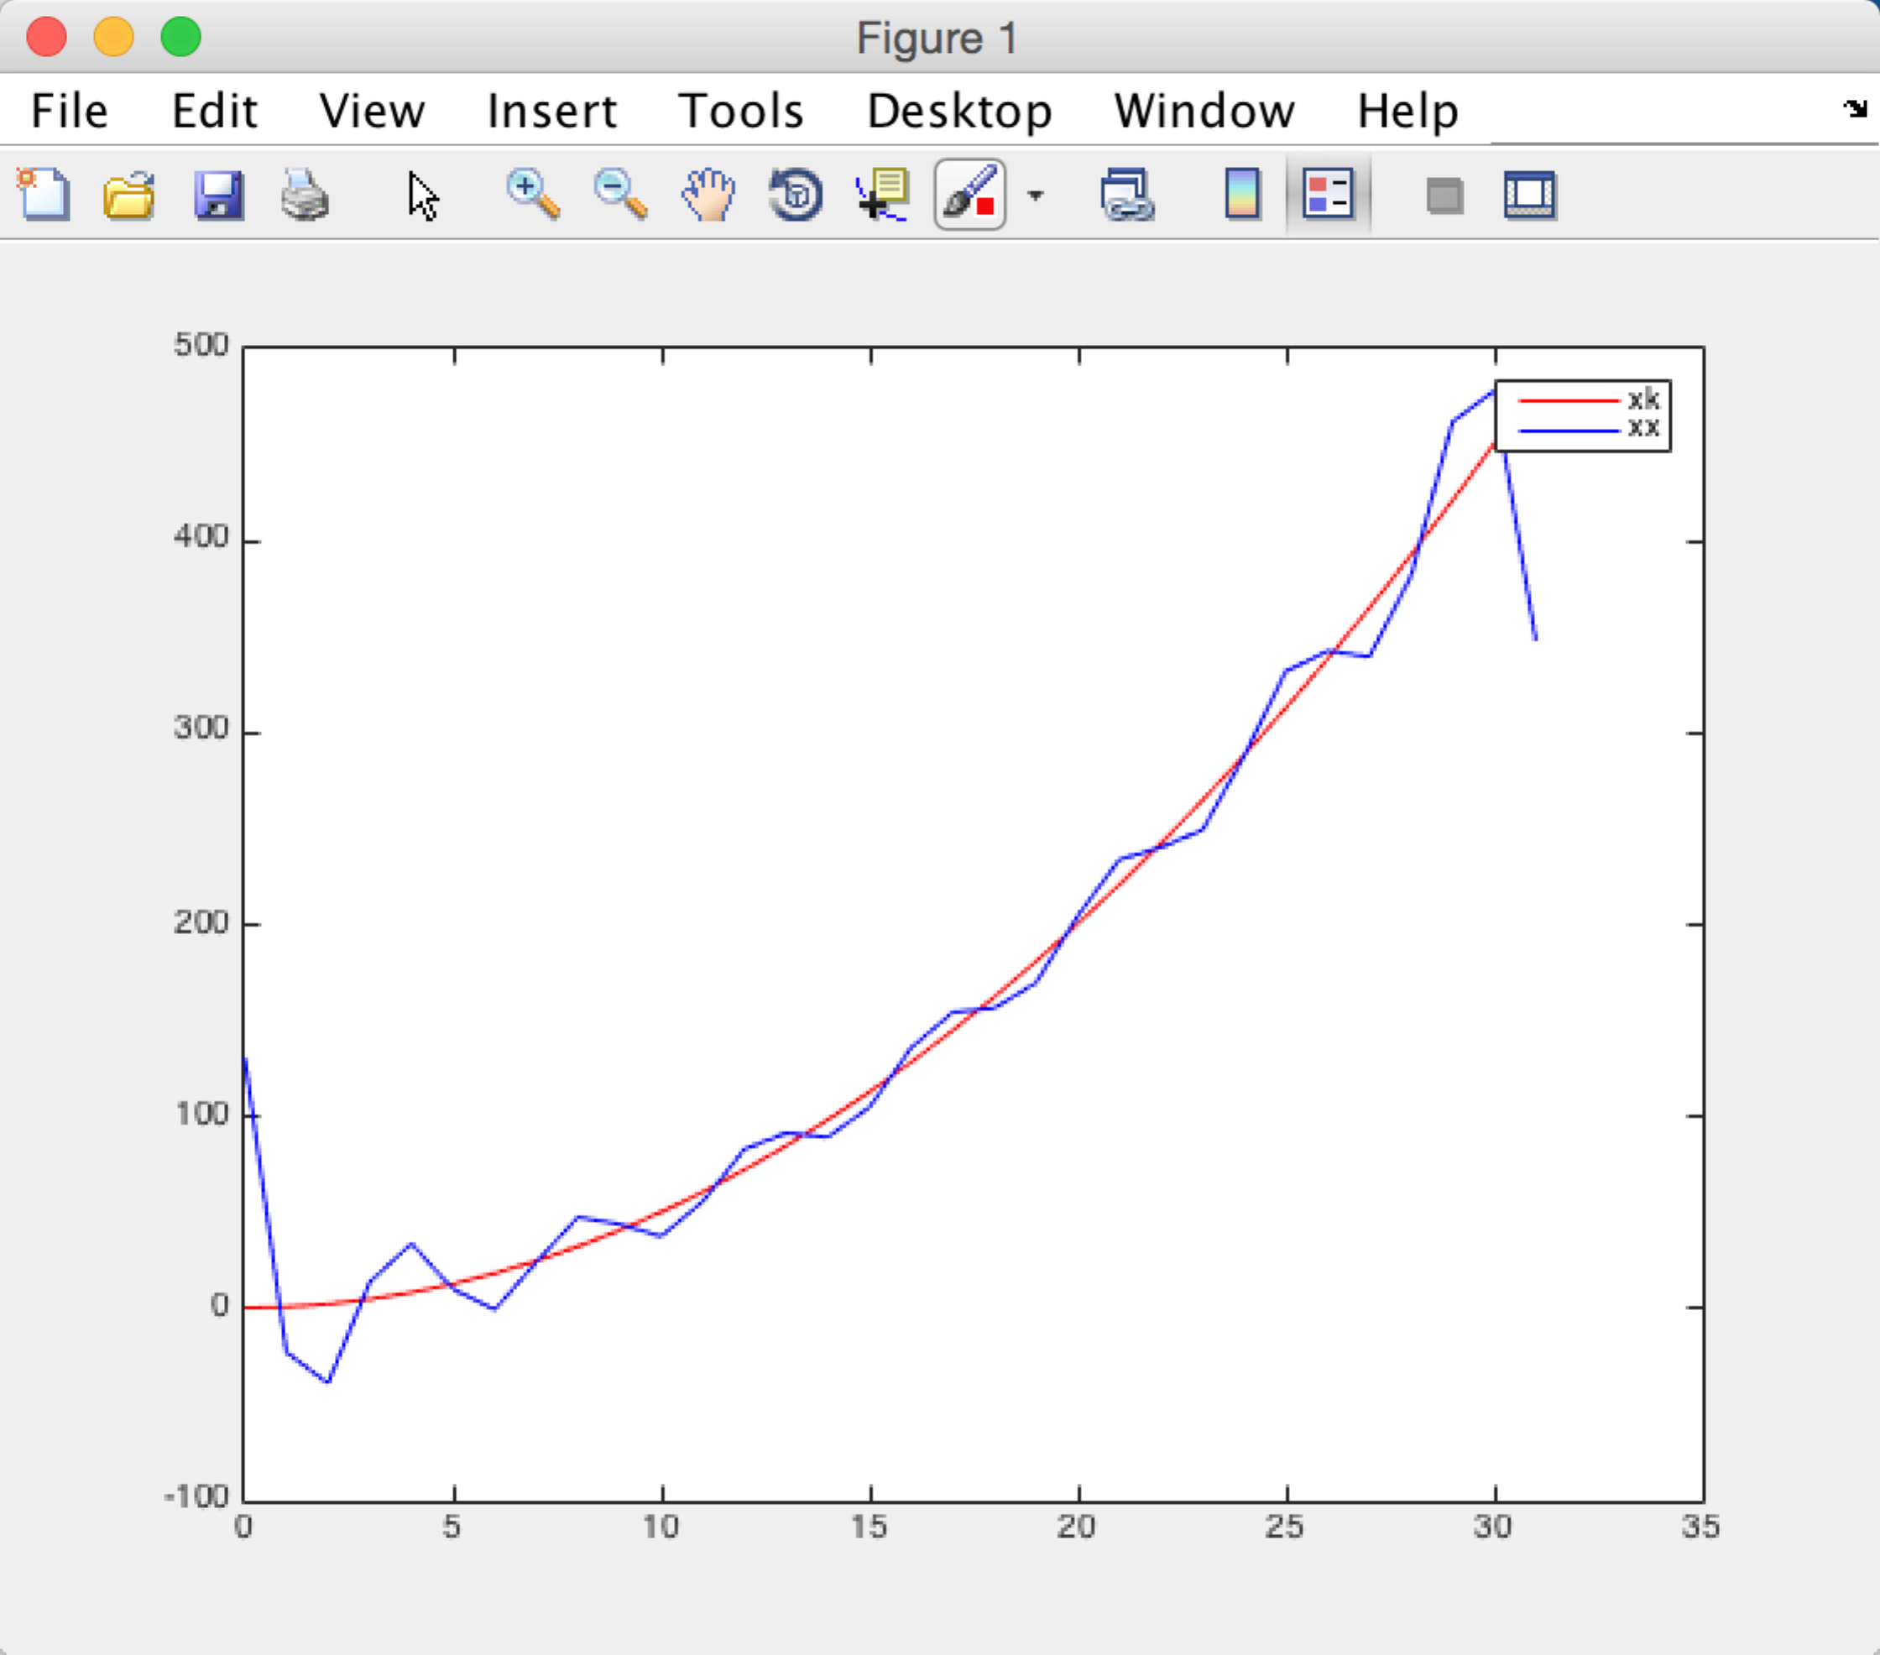

yk and yy

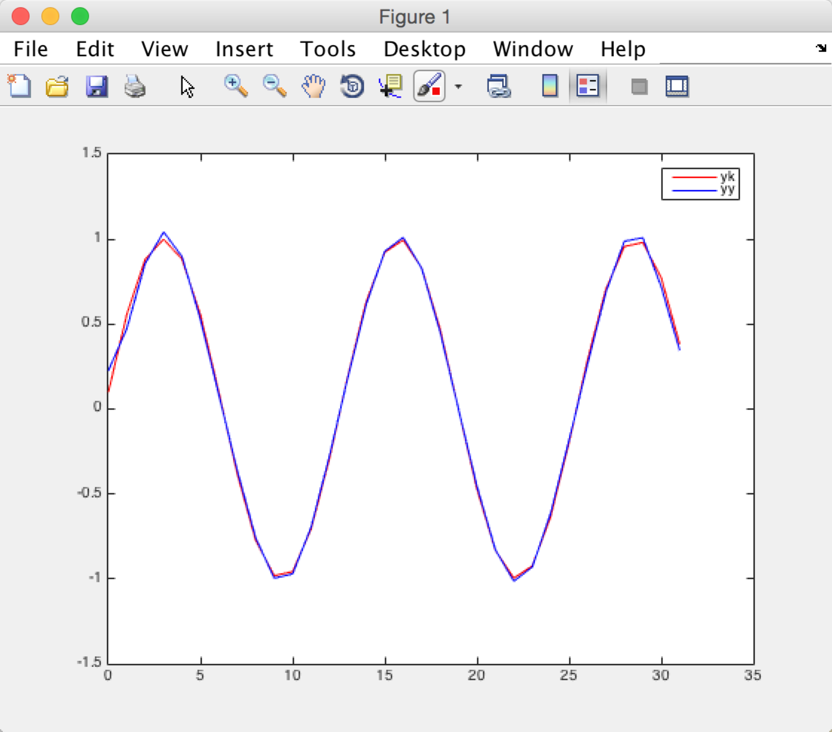

Problem 3

Here is the code to solve the question:

clear

k = [0:1:31]

xk = (k.^2 + 1)/2

yk = sin((5\*k+1)\*pi/32)

X = dct(xk')

Y = dct(yk')

XX = X

YY = Y

XX(16:length(XX)) = 0

YY(16:length(YY)) = 0

xx = idct(XX)

yy = idct(YY)

plot(k,xk,'r',k,xx,'b')

legend('xk','xx')

plot(k,yk,'r',k,yy,'b')

legend('yk','yy')

a.

My answer:

X is

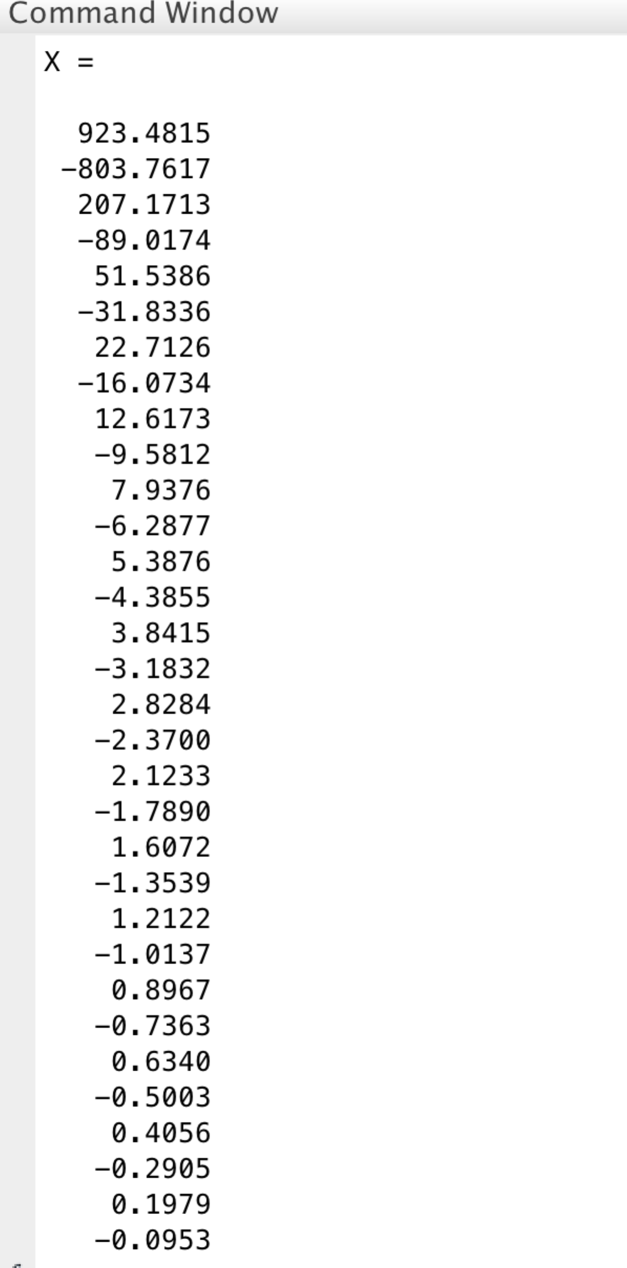

Y is

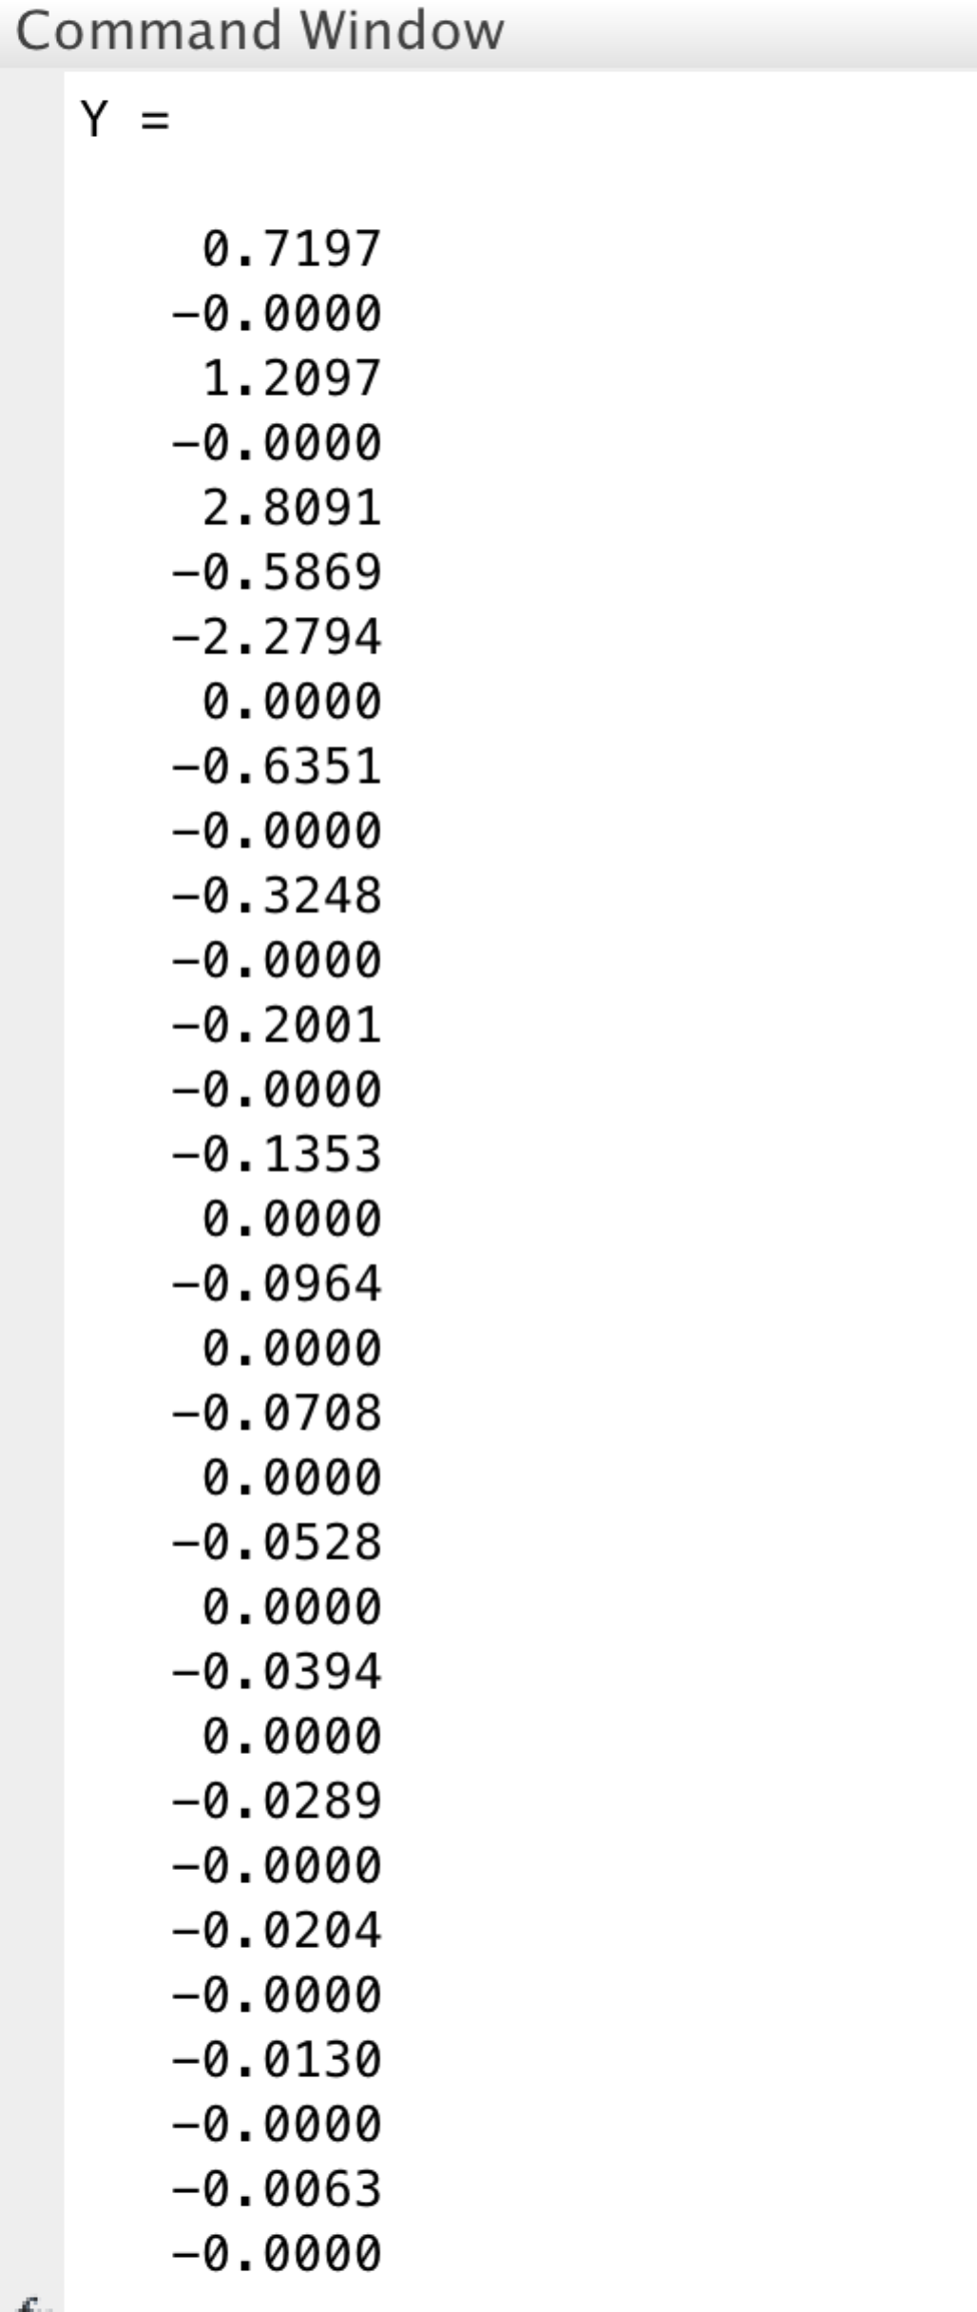

Inverse x is

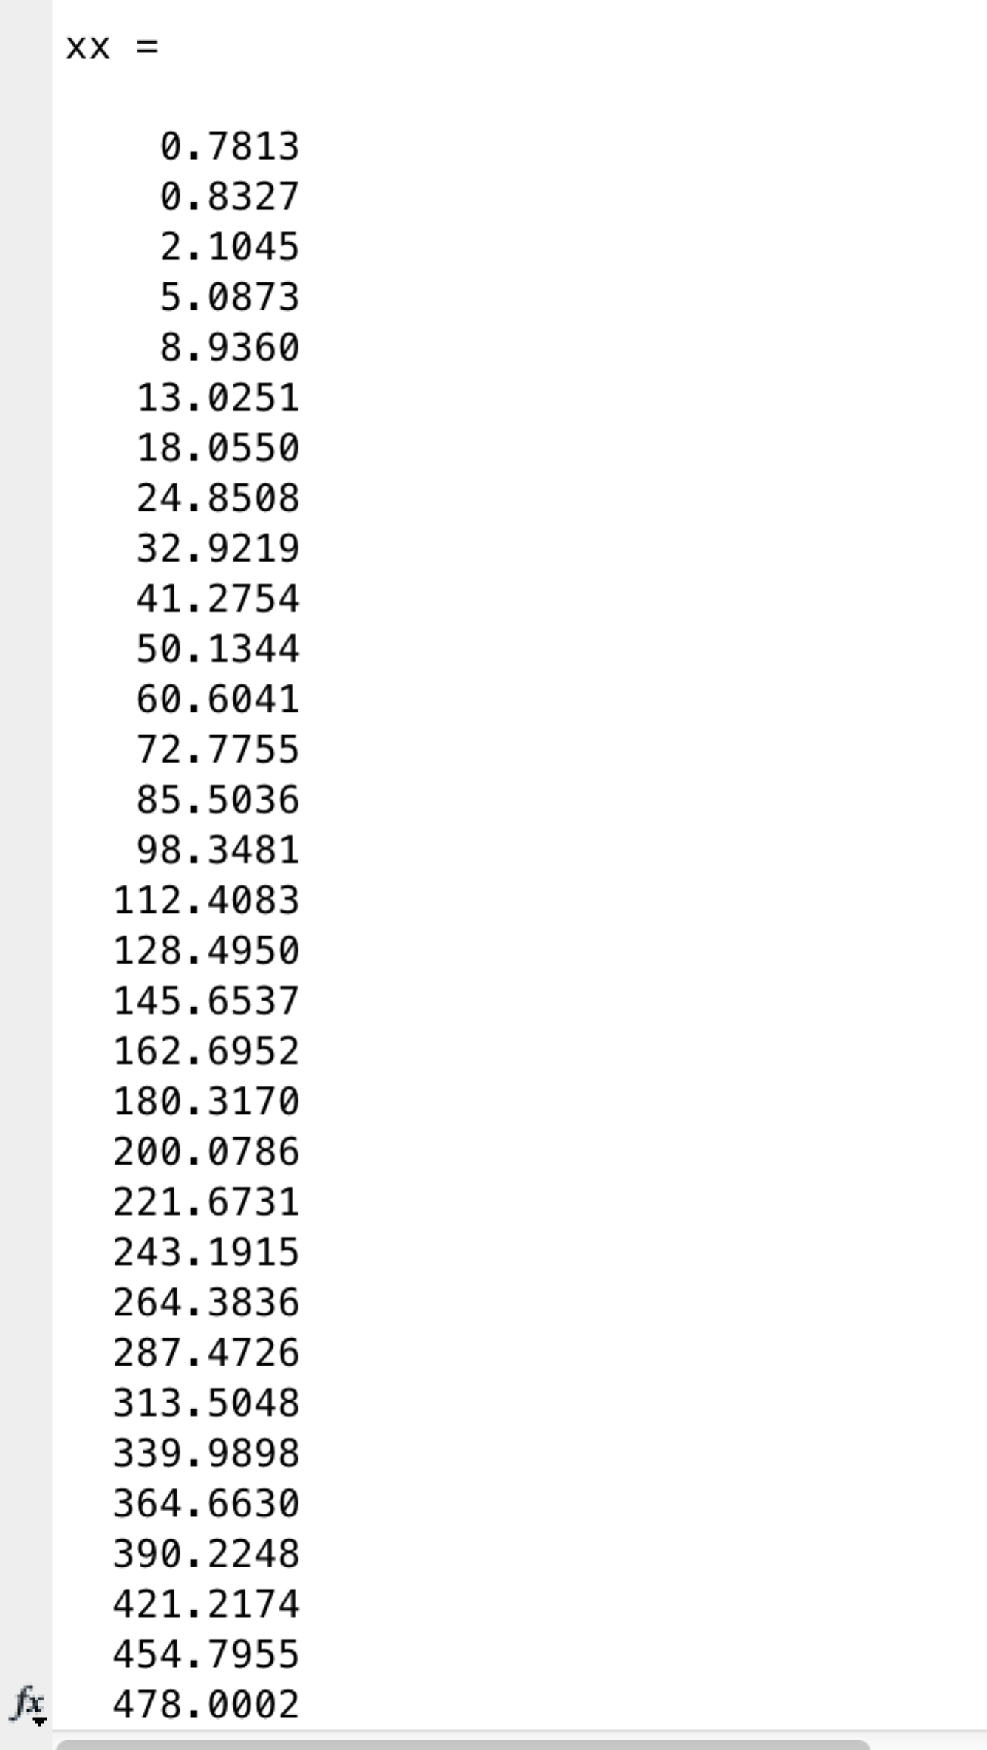

inverse y is

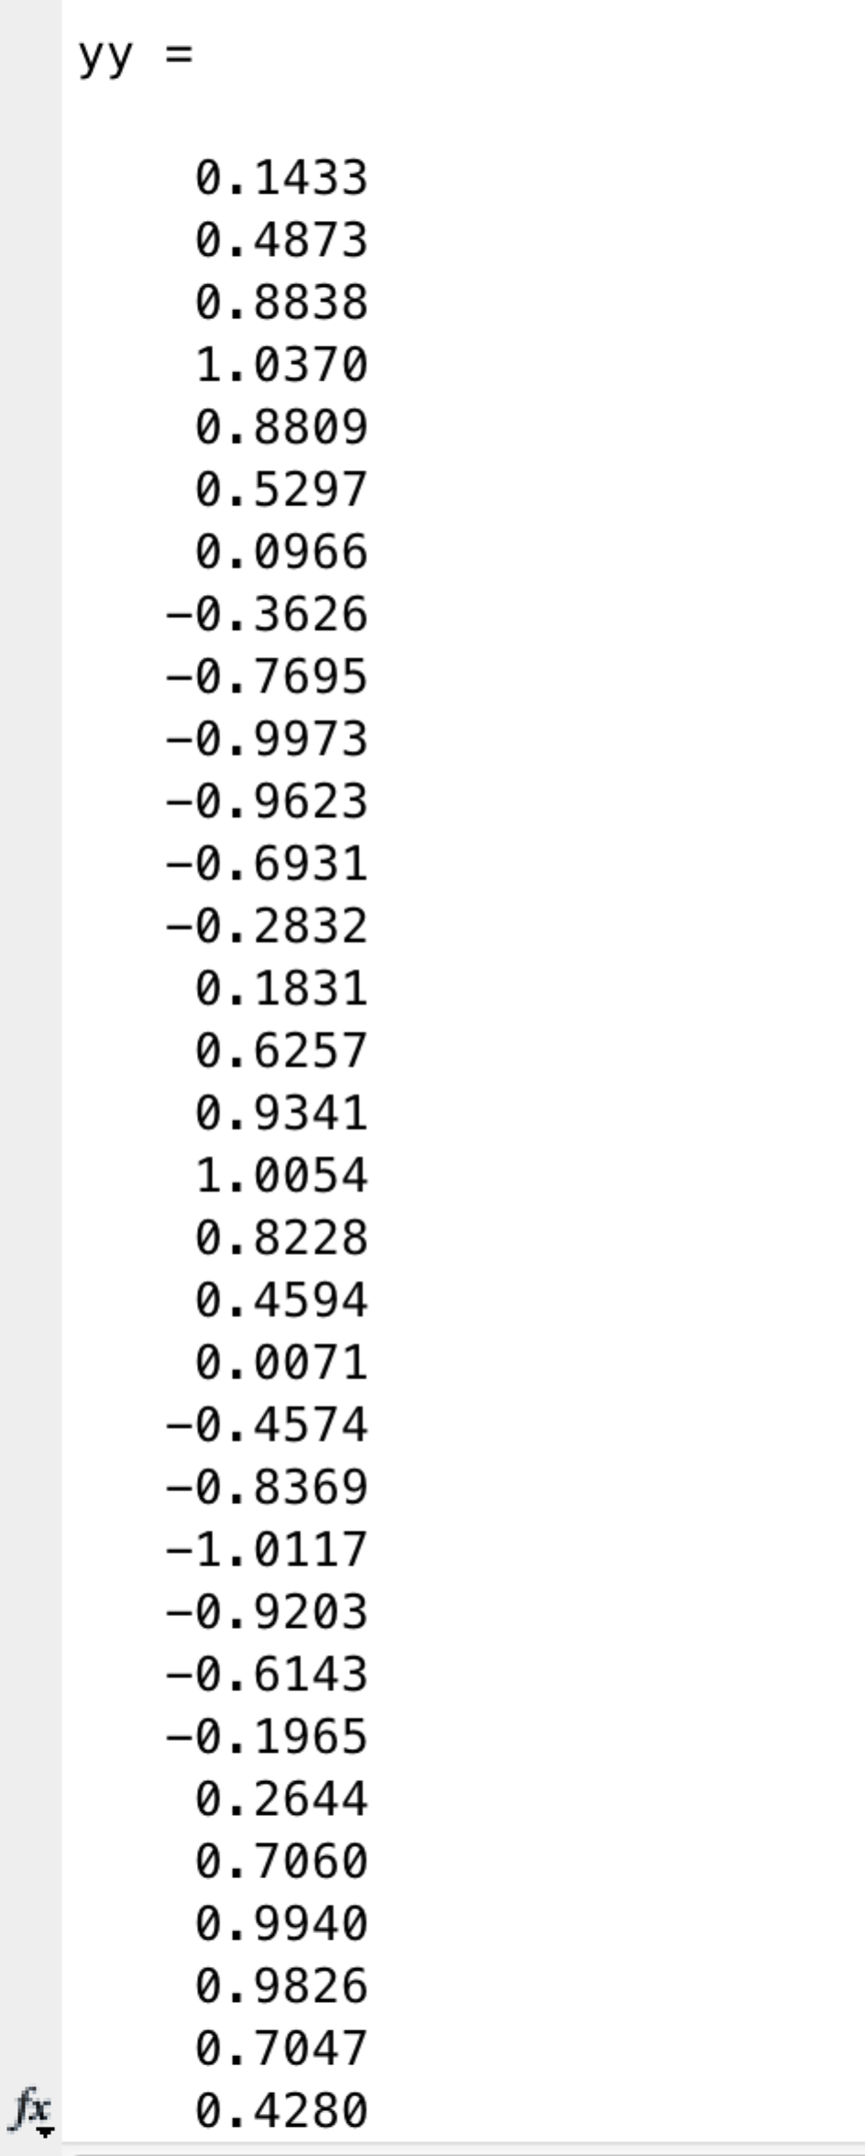

The figures are :

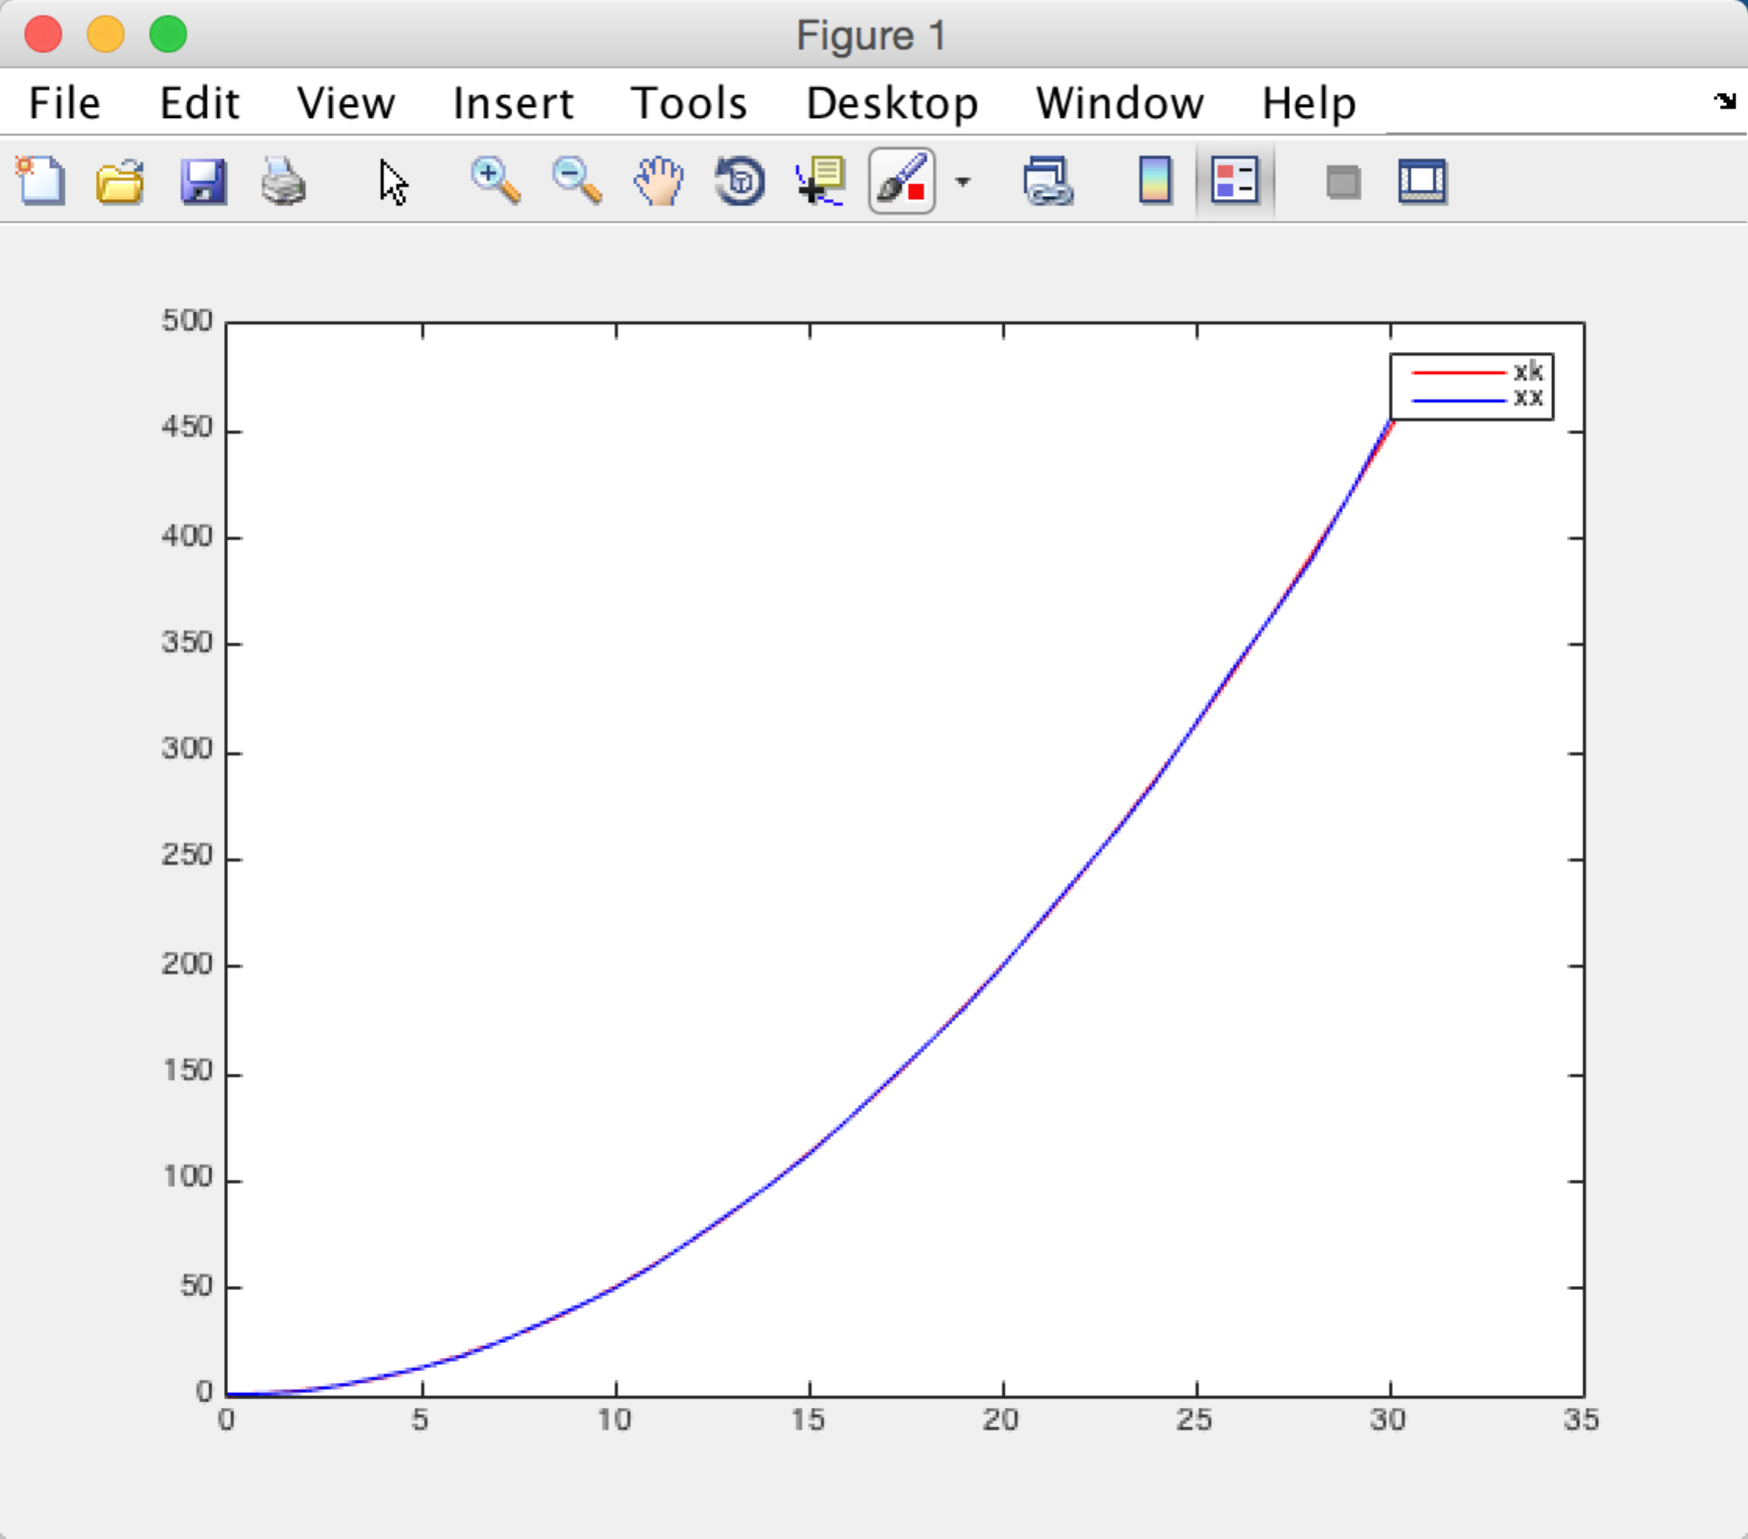

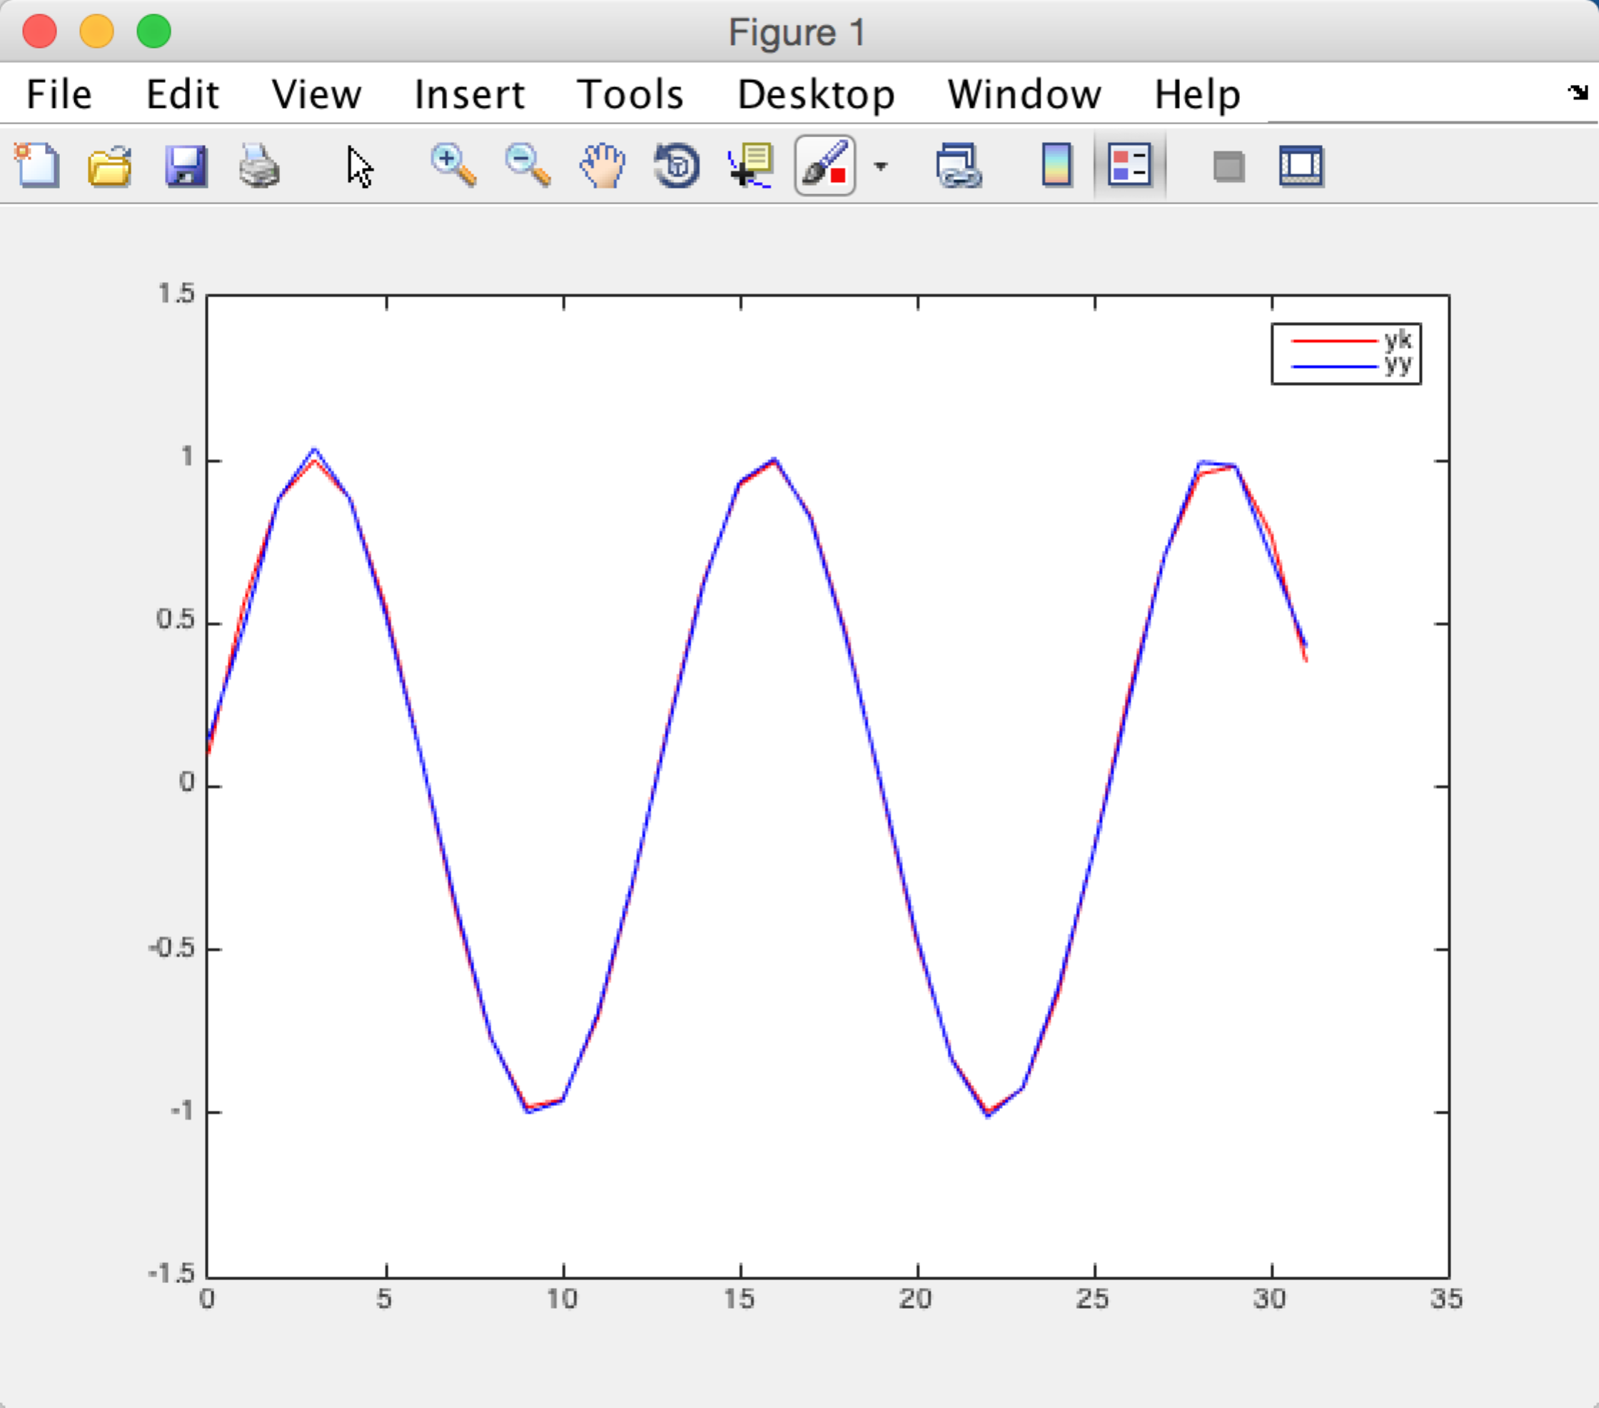

Question 4

Because I don’t find the haar transform method in matlab, so I find one function to generate haar transform matrix on Internet.

Here is the code:

function H=haarmtx(n)

a=1/sqrt(n);

for i=1:n

H(1,i)=a;

end

for k=1:n-1

p=fix(log2(k));

q=k-2^p+1;

t1=n/2^p;

sup=fix(q\*t1);

mid=fix(sup-t1/2);

inf=fix(sup-t1);

t2=2^(p/2)\*a;

for j=1:inf

H(k+1,j)=0;

end

for j=inf+1:mid

H(k+1,j)=t2;

end

for j=mid+1:sup

H(k+1,j)=-t2;

end

for j=sup+1:n

H(k+1,j)=0;

end

end

it generates the right results of haar matrix.

Here is my code to solve the question:

a.

clear

k = [0:1:31]

xk = (k.^2 + 1)/2

yk = sin((5\*k+1)\*pi/32)

X = haarmtx(32)\*xk'

Y = haarmtx(32)\*yk'

% X = fft(xk')

% Y = fft(yk')

MX = abs(X)

MY = abs(Y)

TRY1 = sortrows(MX)

TRY2 = sortrows(MY)

MX17 = TRY1(1:17)

MY17 = TRY2(1:17)

XX = X

YY = Y

for i = 1:length(XX)

if(ismember(abs(XX(i)),MX17))

XX(i) = 0

end

end

for i = 1:length(YY)

if(ismember(abs(YY(i)),MY17))

YY(i) = 0

end

end

xx = inv(haarmtx(32))\*(XX)

yy = inv(haarmtx(32))\*(YY)

% xx = haarmtx(32)'\*XX

% yy = haarmtx(32)'\*YY

plot(k,xk,'r',k,xx,'b')

legend('xk','xx')

plot(k,yk,'r',k,yy,'b')

legend('yk','yy')

X IS

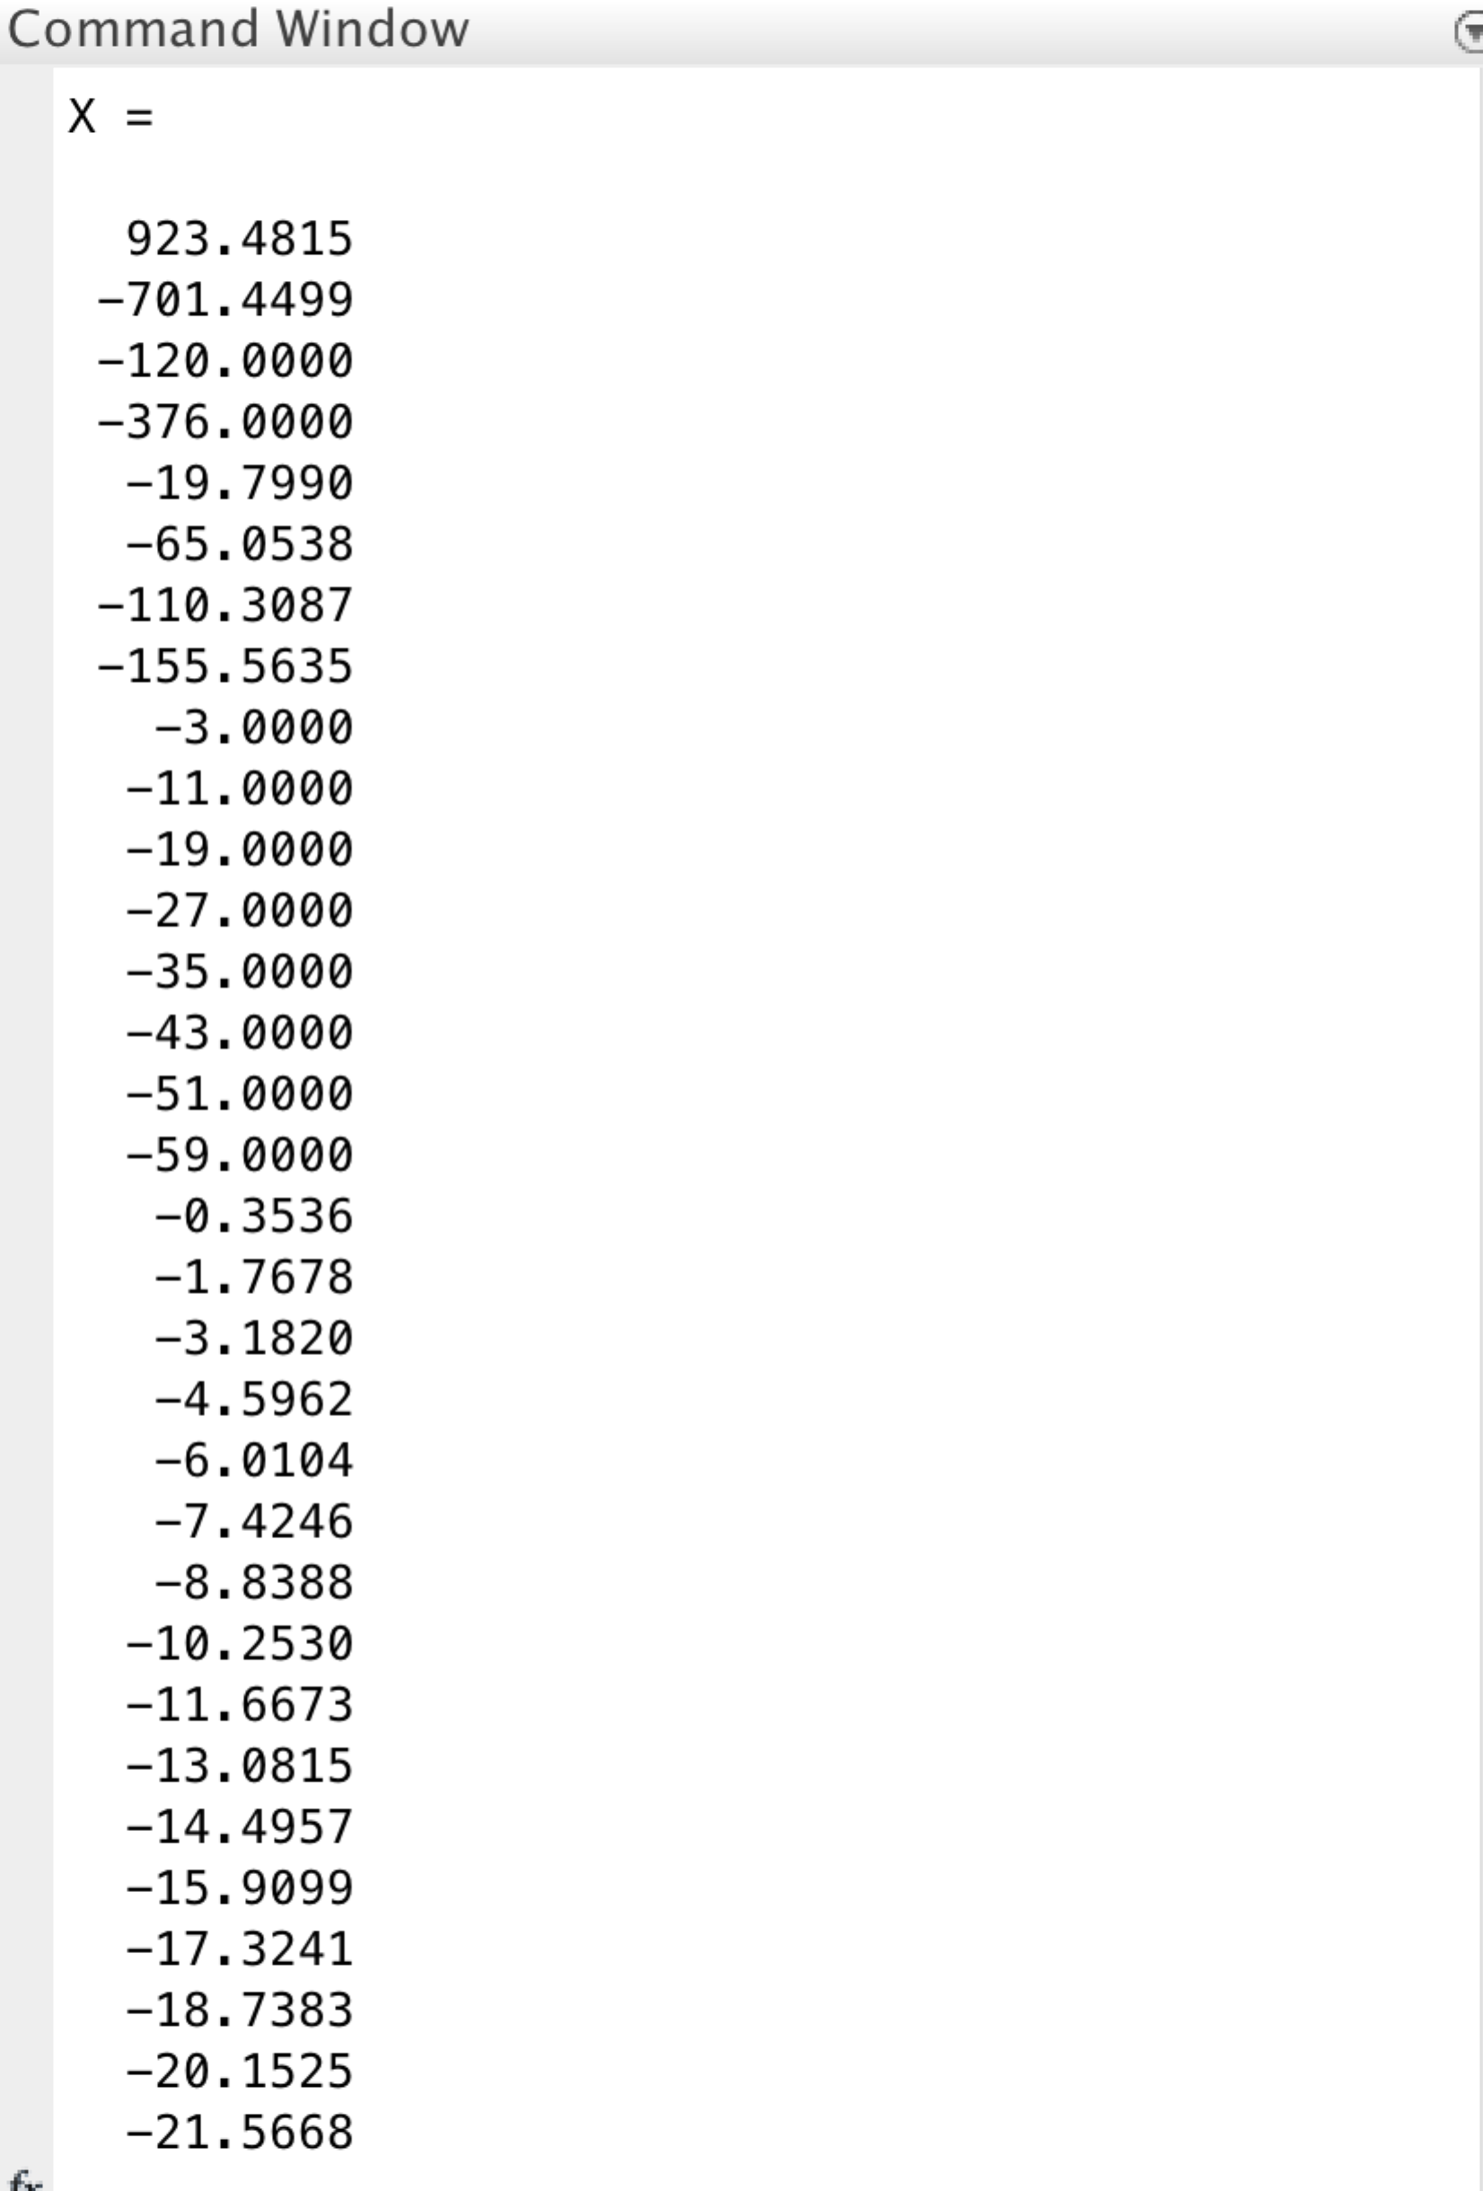

Y IS

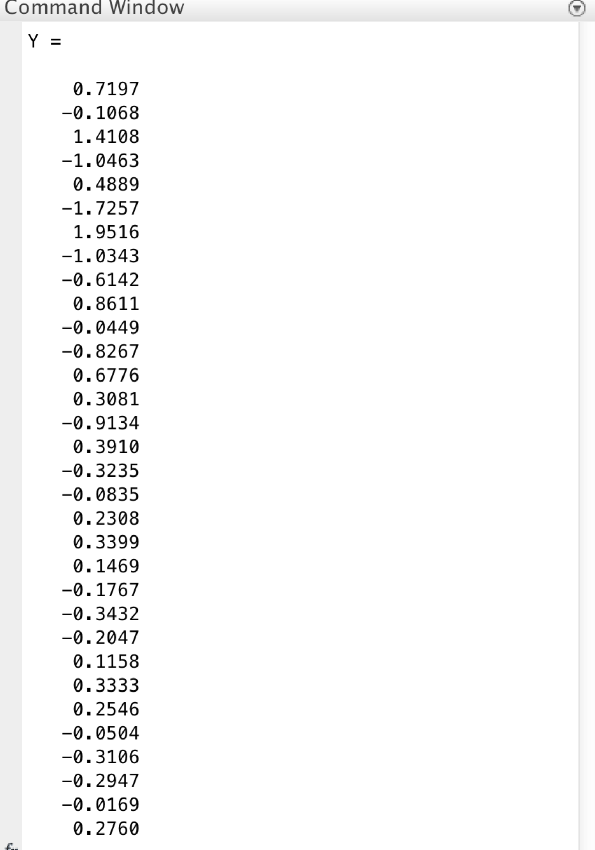

INVERSE X IS

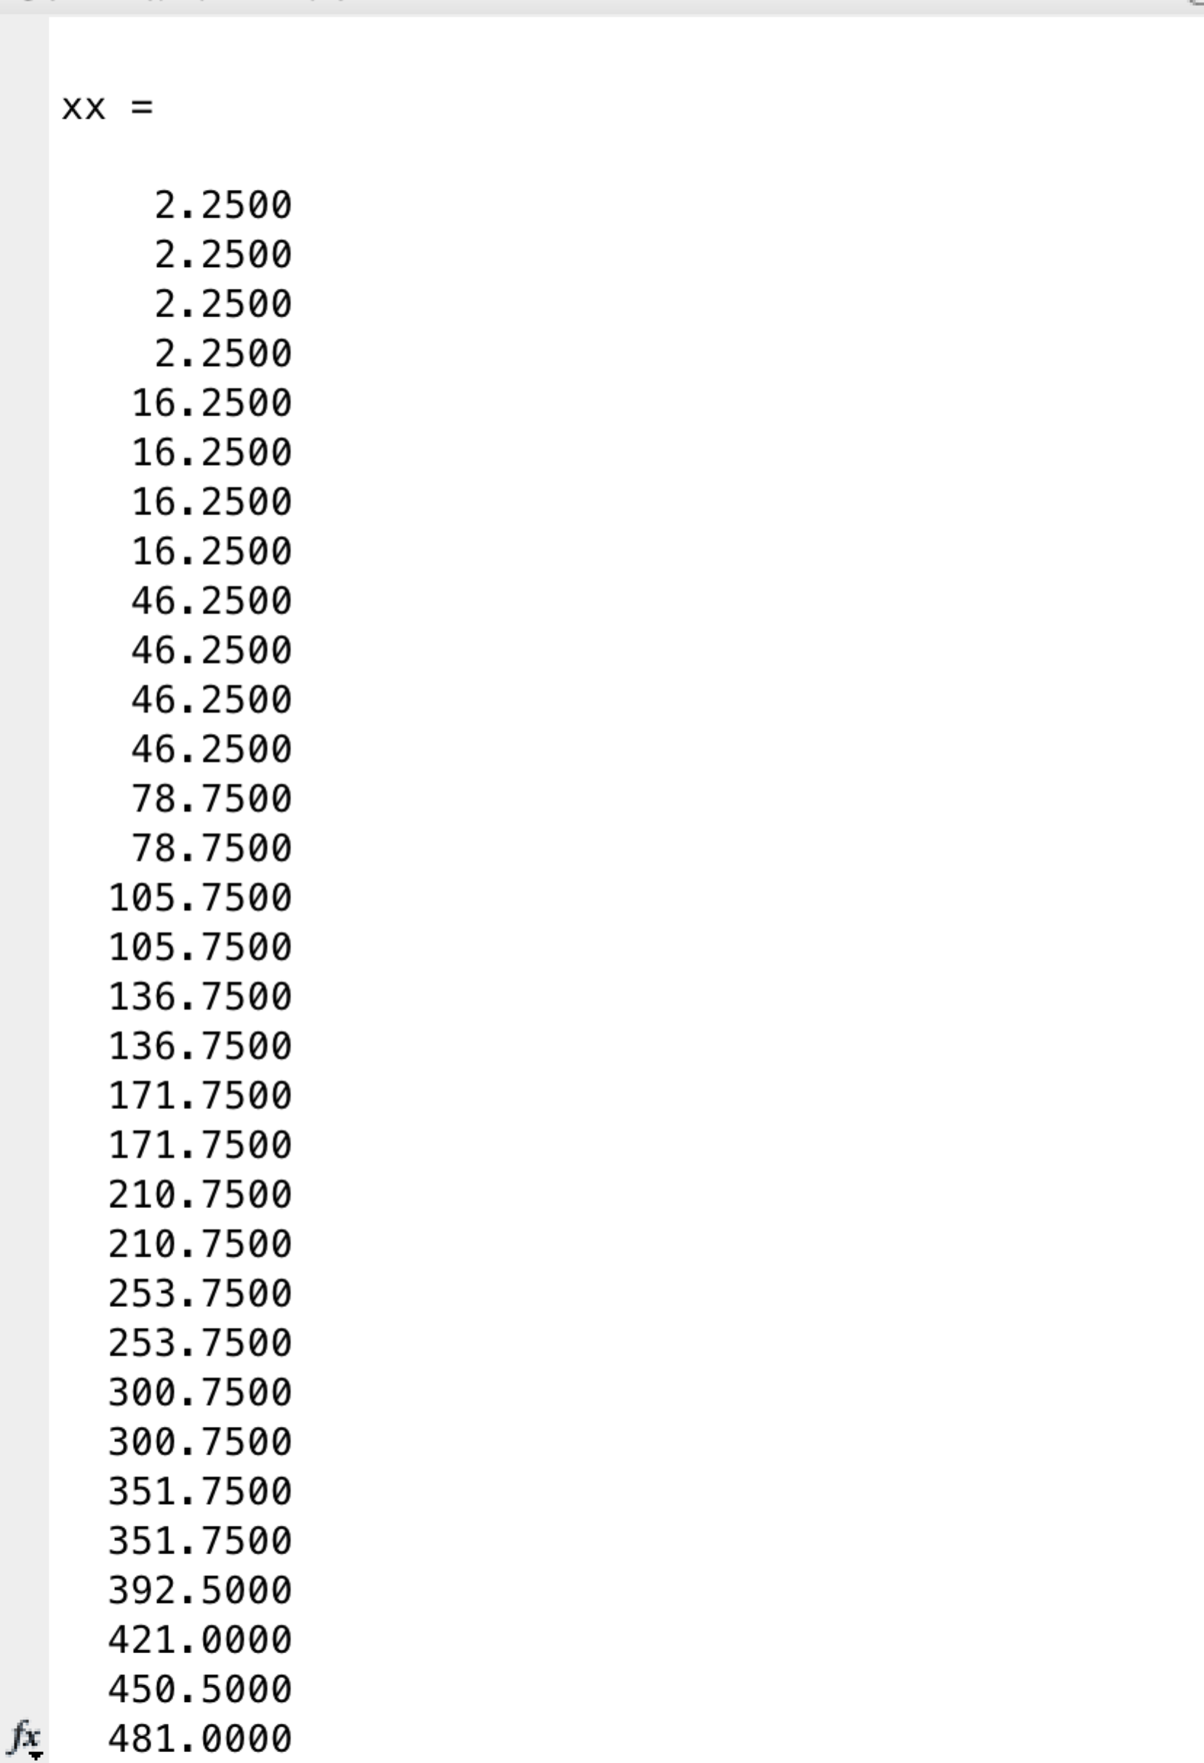

INVERSE Y IS

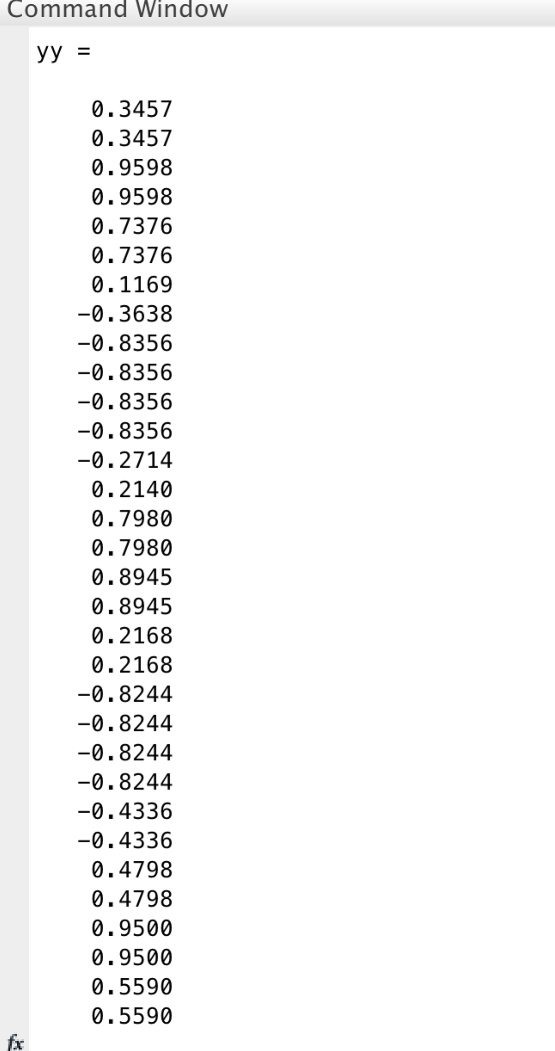

THE FIGURES ARE

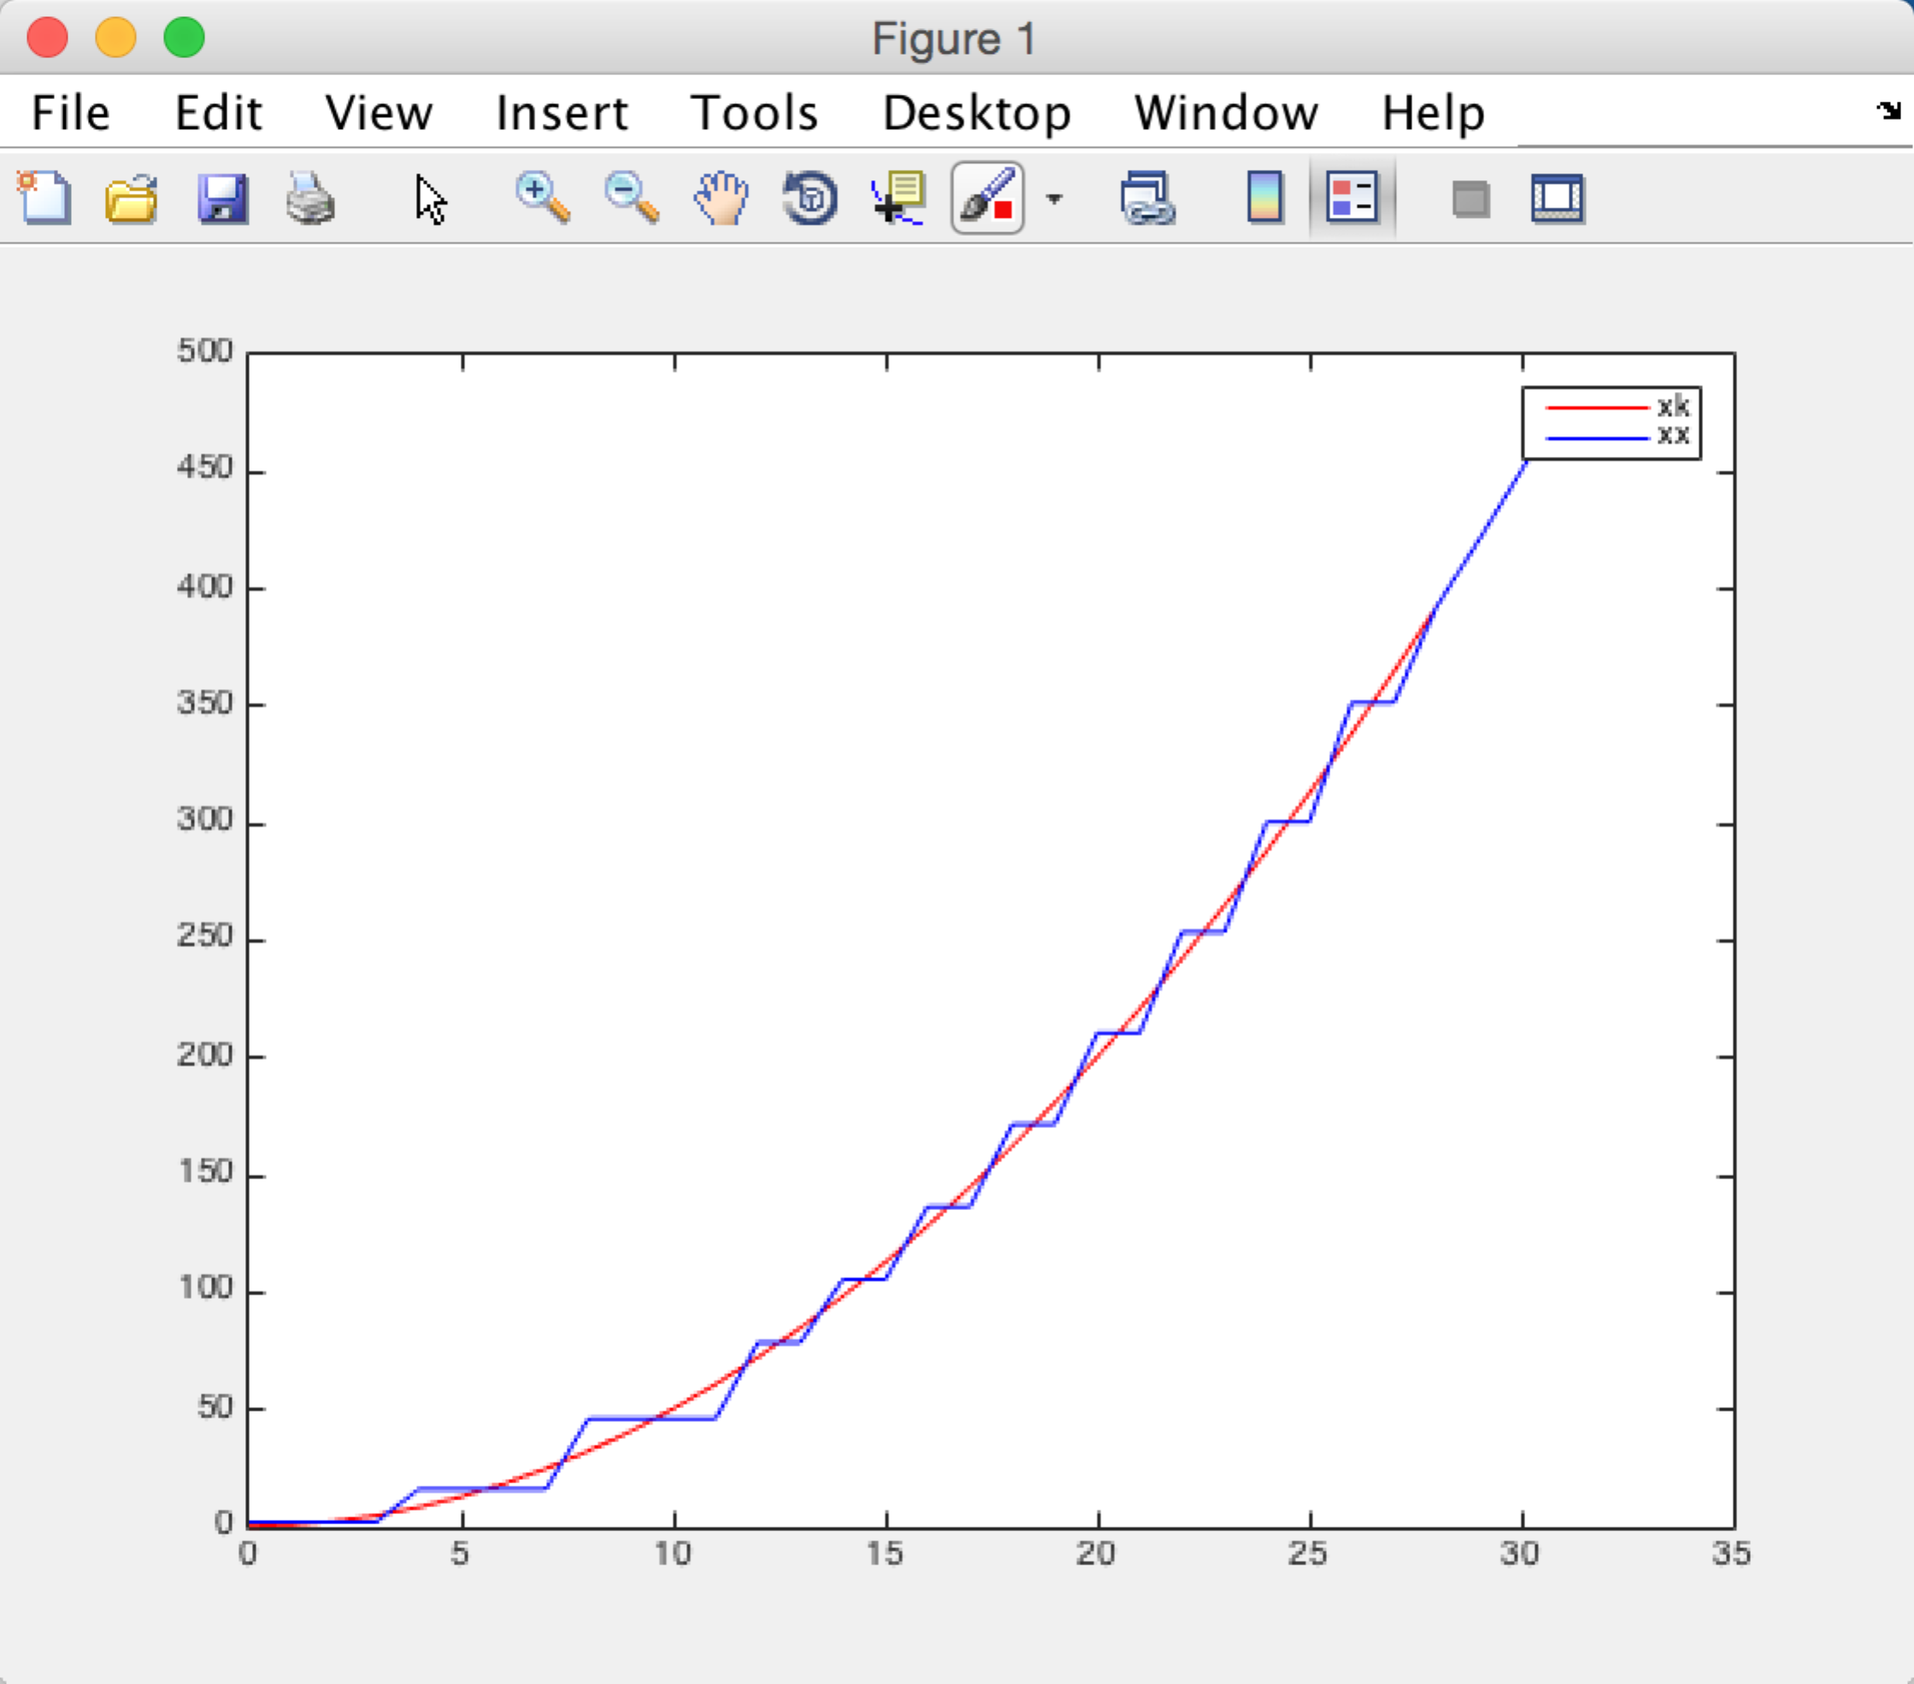

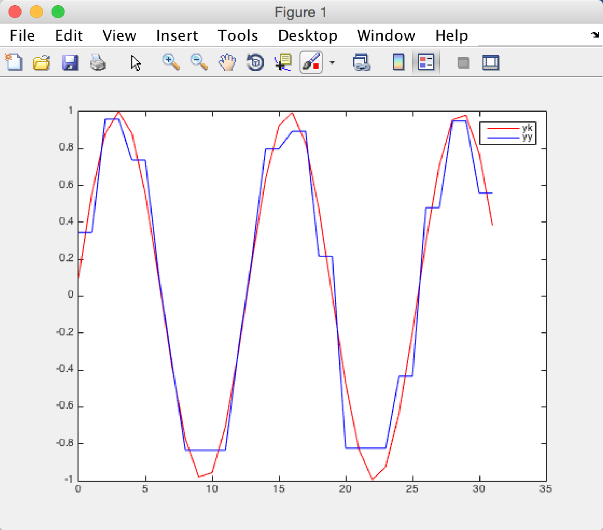

b.

Here is my code to solve the question

clear

k = [0:1:31]

xk = (k.^2 + 1)/2

yk = sin((5\*k+1)\*pi/32)

X = hadamard(32)\*xk'

Y = hadamard(32)\*yk'

MX = abs(X)

MY = abs(Y)

TRY1 = sortrows(MX)

TRY2 = sortrows(MY)

MX17 = TRY1(1:17)

MY17 = TRY2(1:17)

XX = X

YY = Y

for i = 1:length(XX)

if(ismember(abs(XX(i)),MX17))

XX(i) = 0

end

end

for i = 1:length(YY)

if(ismember(abs(YY(i)),MY17))

YY(i) = 0

end

end

xx = inv(hadamard(32))\*(XX)

yy = inv(hadamard(32))\*(YY)

% xx = haarmtx(32)'\*XX

% yy = haarmtx(32)'\*YY

plot(k,xk,'r',k,xx,'b')

legend('xk','xx')

plot(k,yk,'r',k,yy,'b')

legend('yk','yy')

X IS :

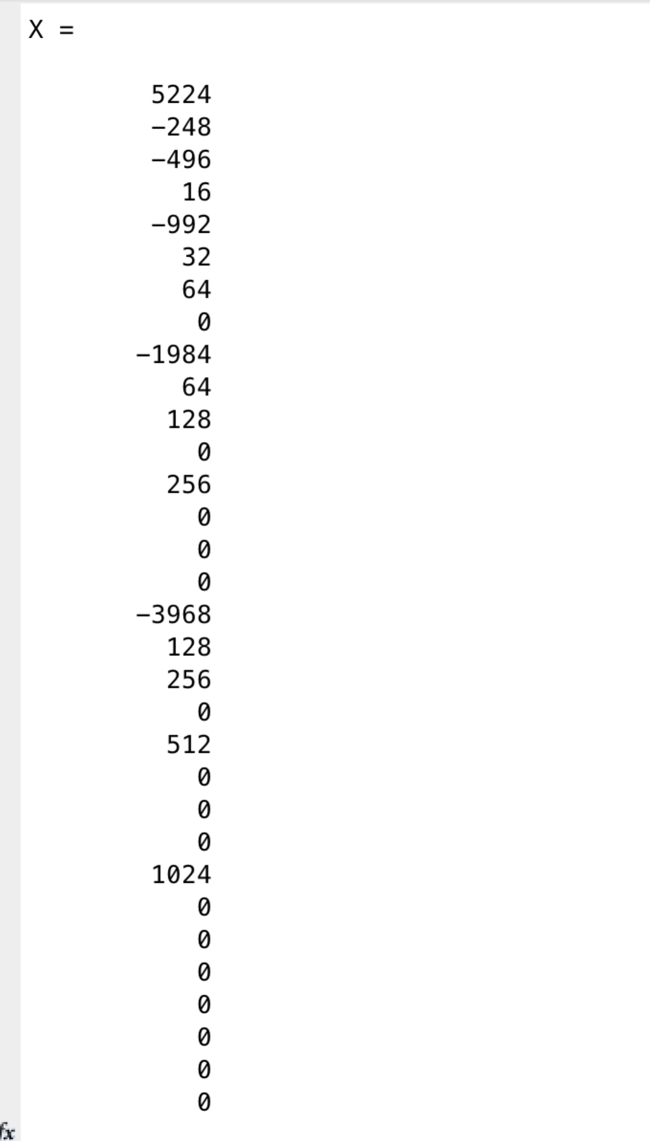

Y IS

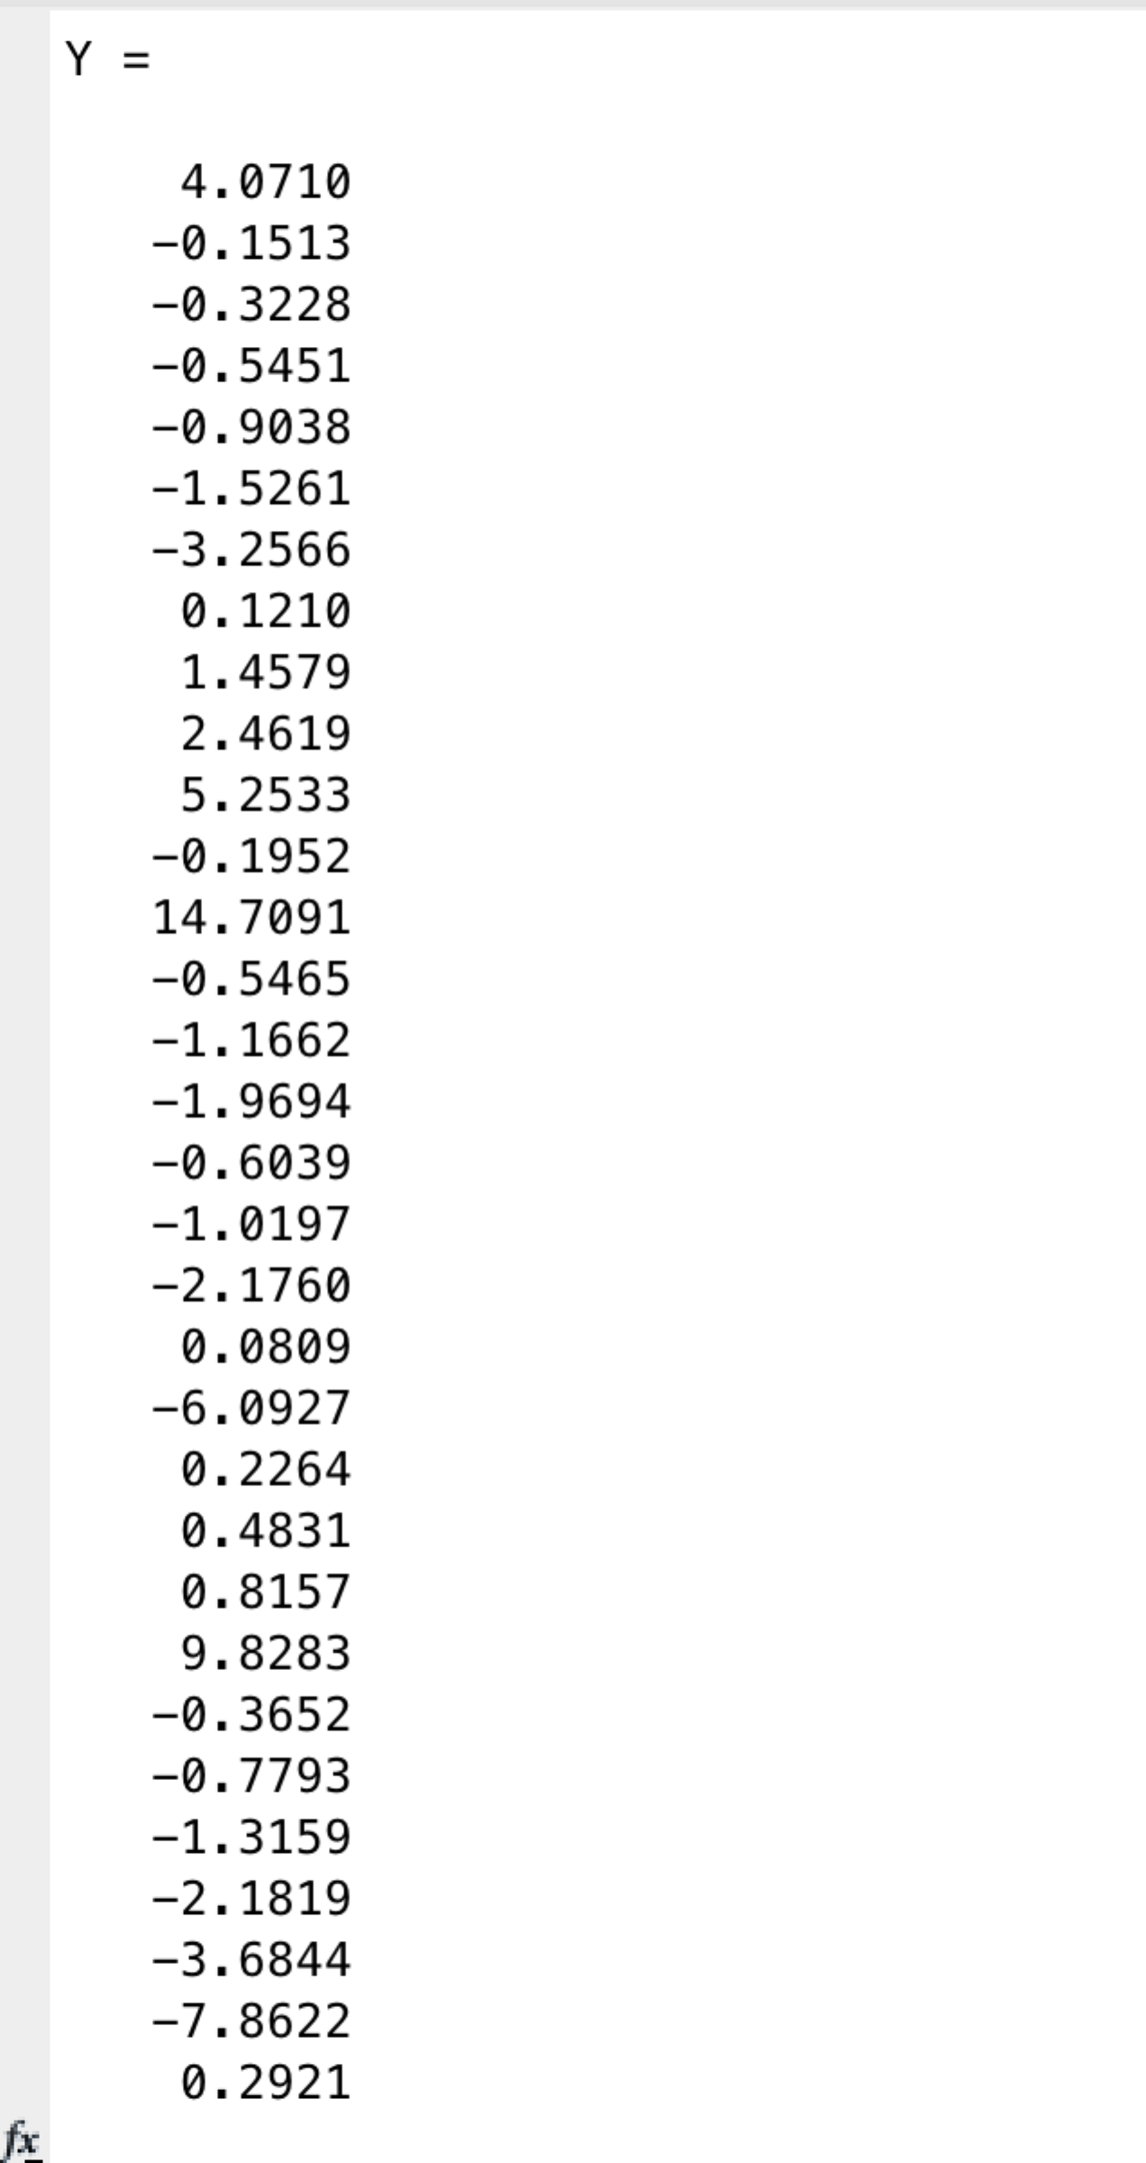

INVERSE X IS

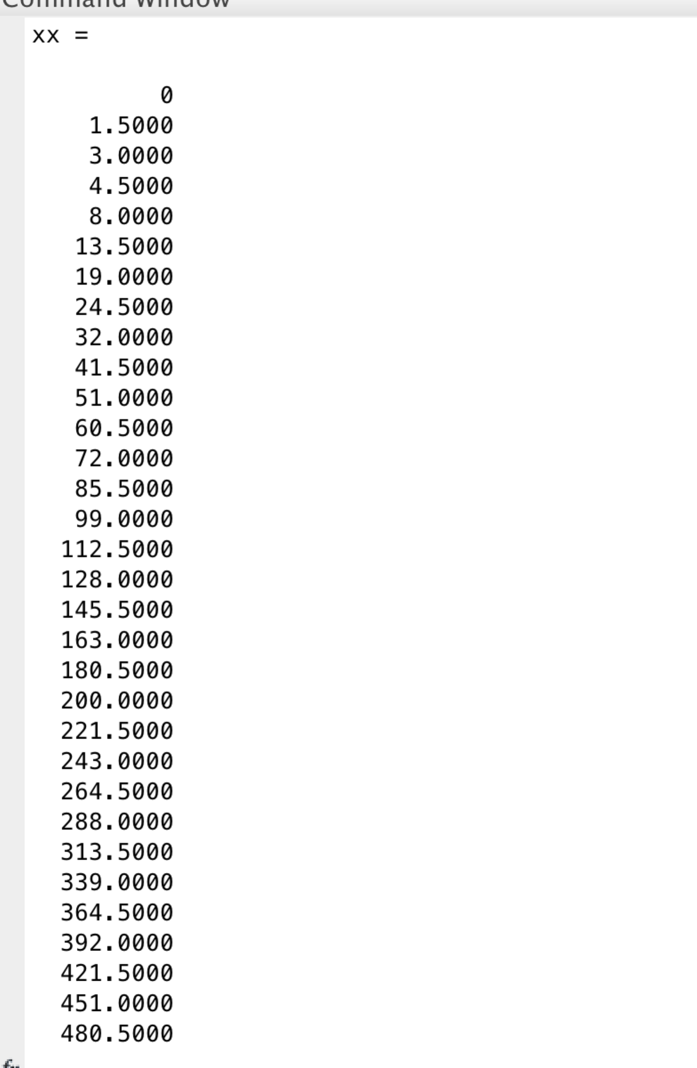

INVERSE Y

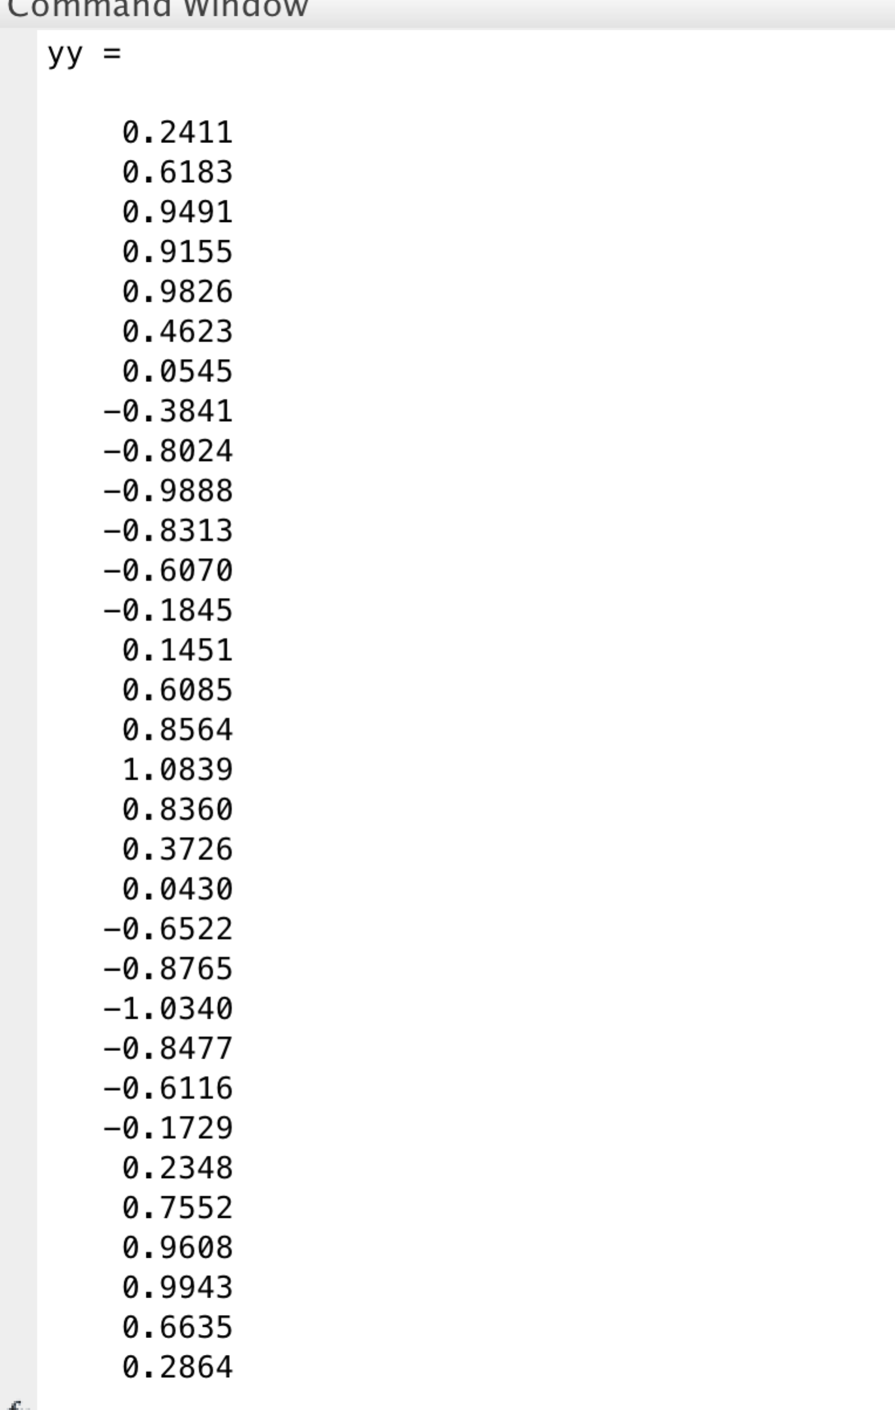

THE FIGURES ARE

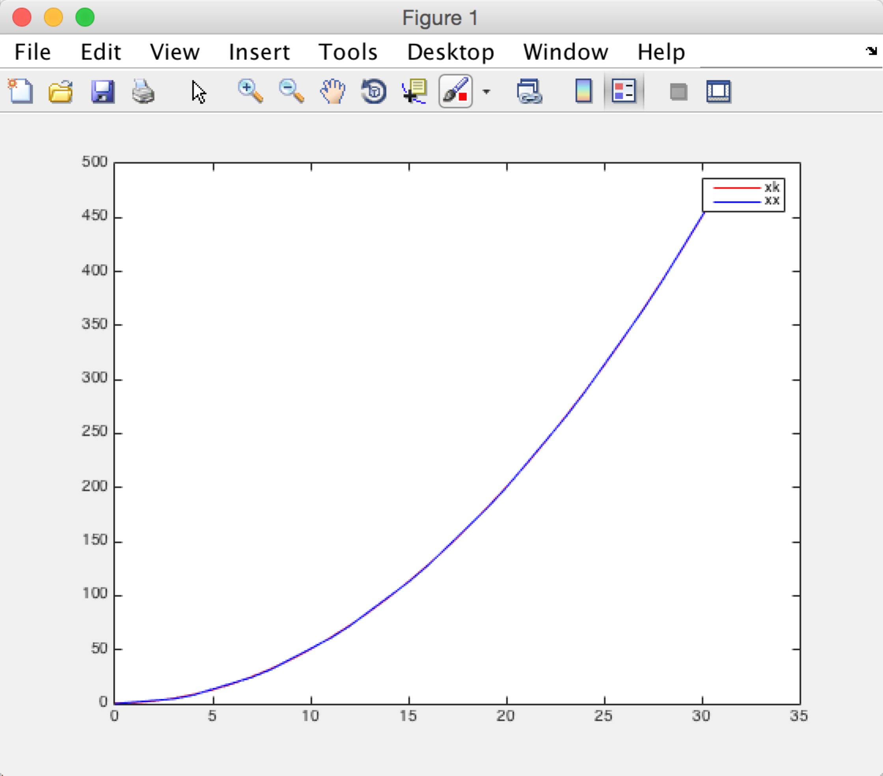

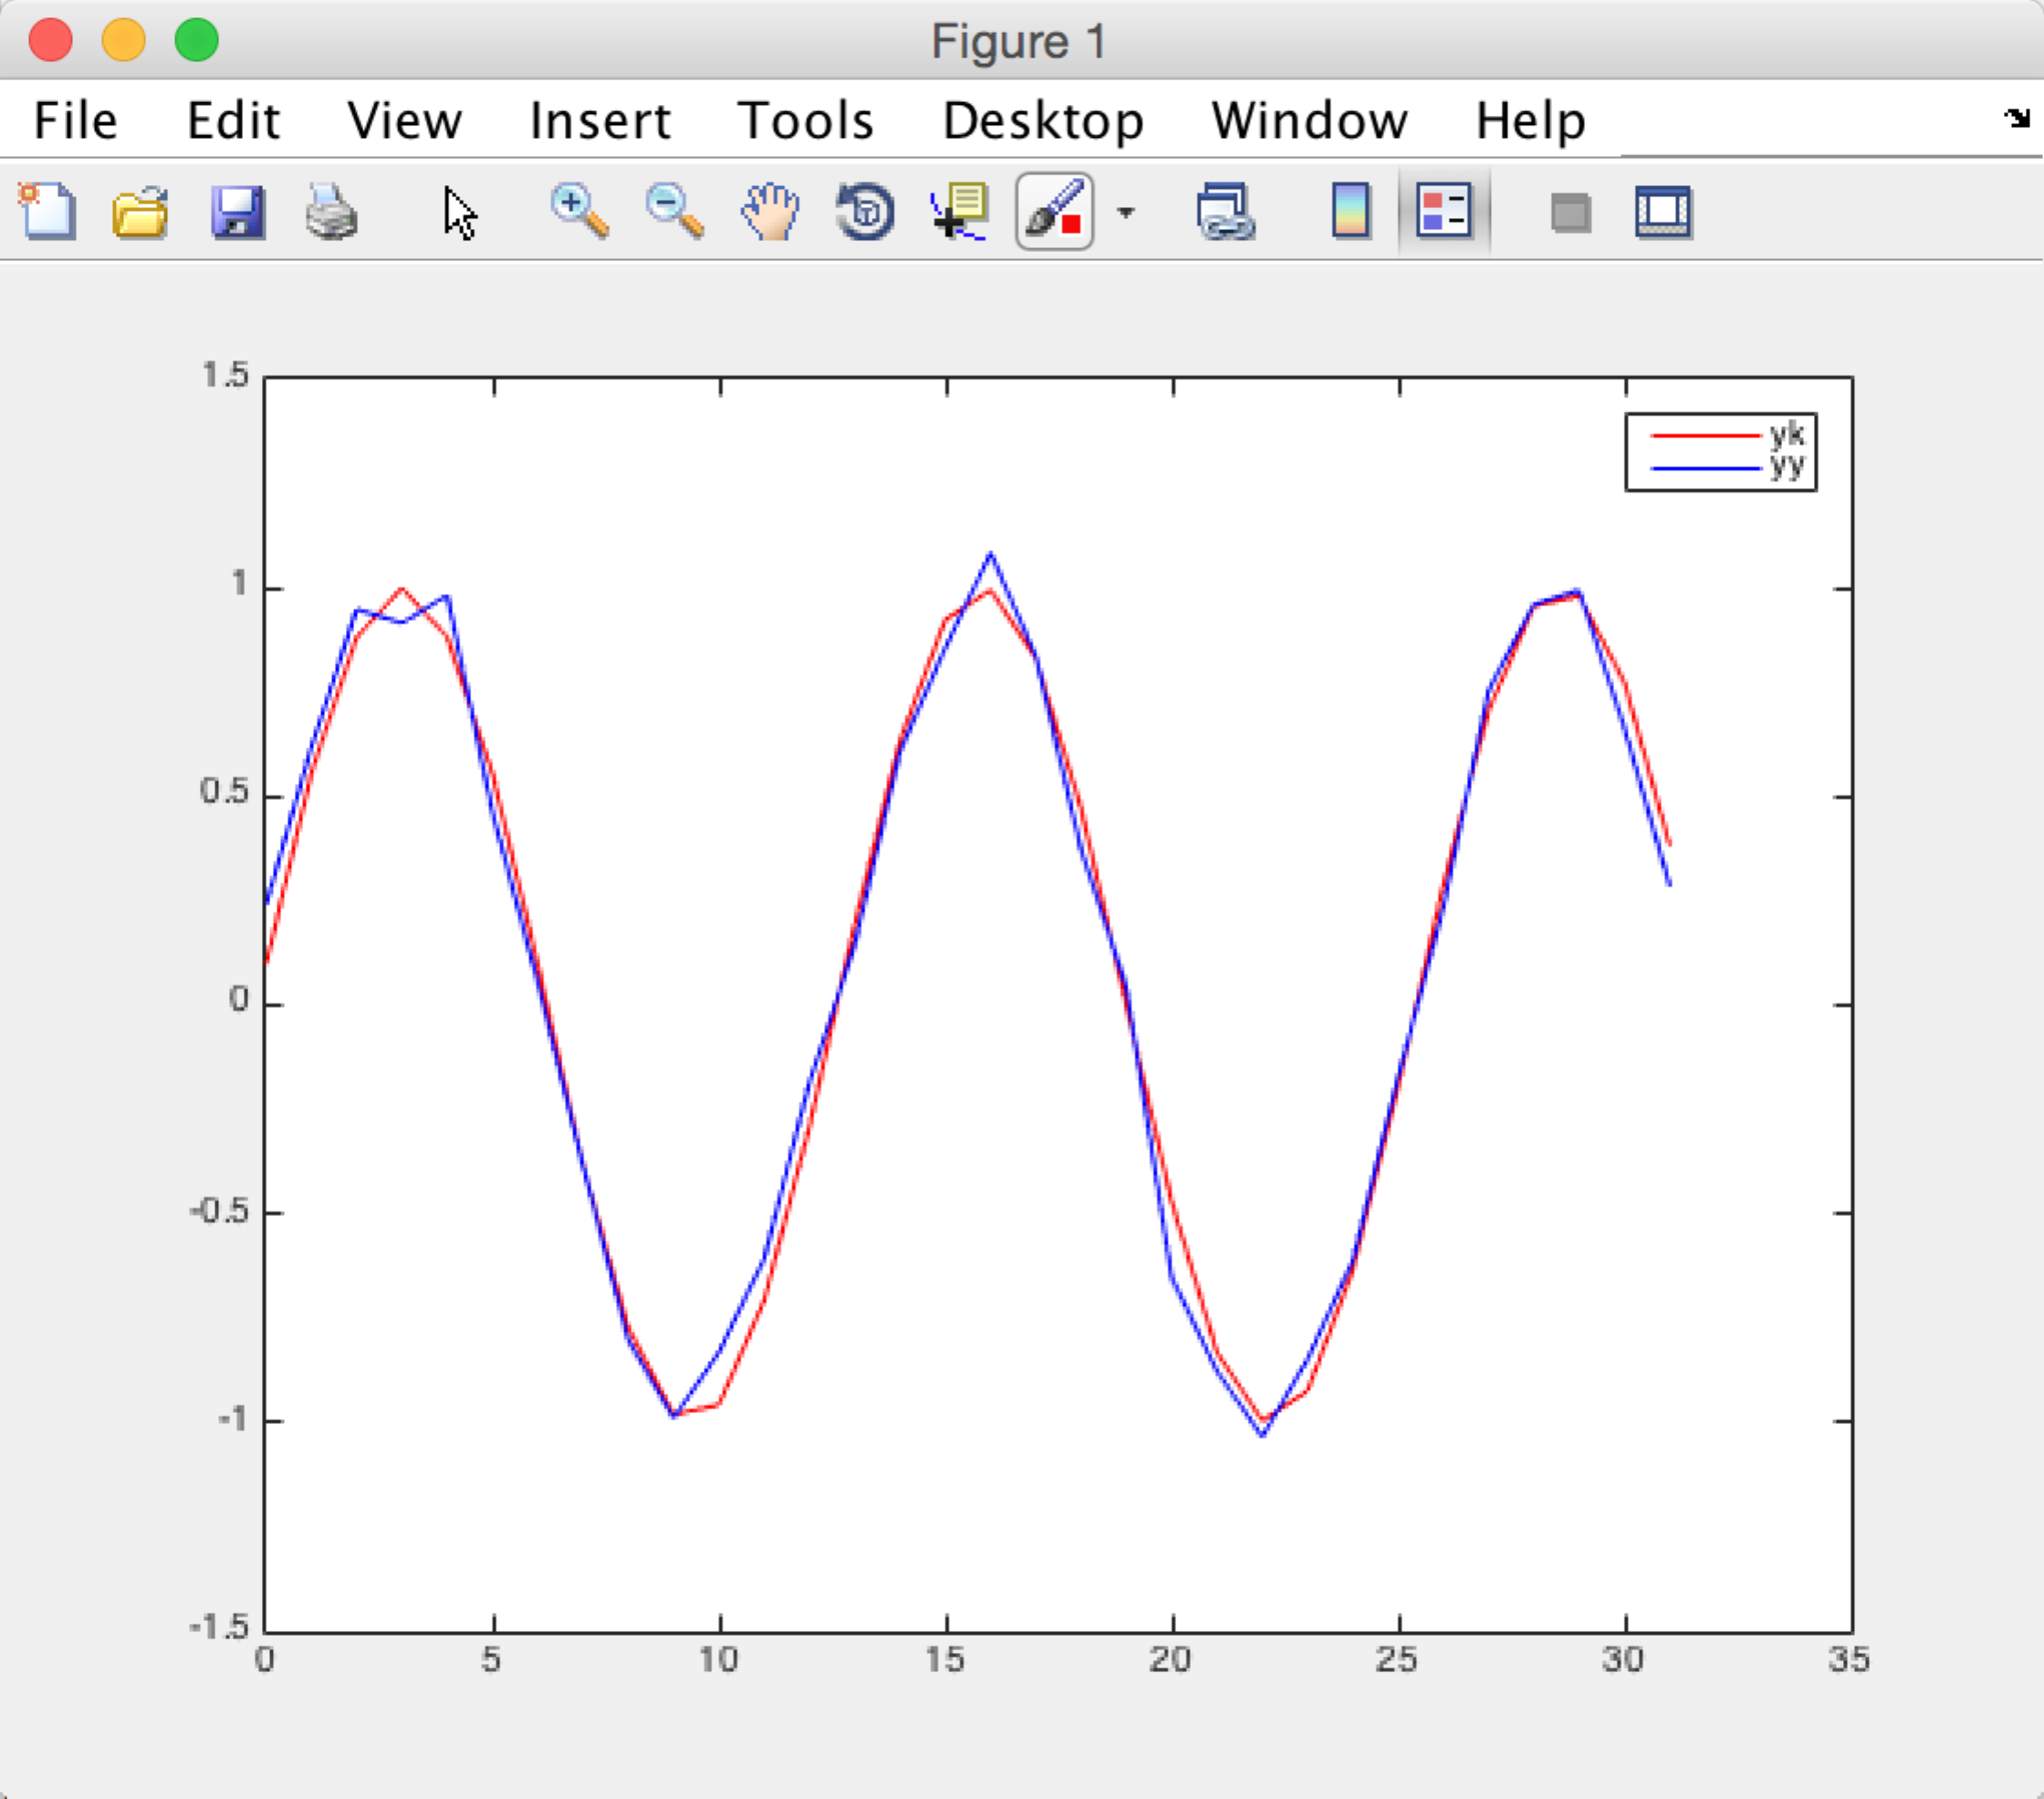

Problem 5

For x and all four inverse x, the code is

clear

k = [0:1:31]

xk = (k.^2 + 1)/2

X = fft(xk')

MX = abs(X)

TRY1 = sortrows(X)

MX17 = TRY1(1:17)

XX = X

for i = 1:length(XX)

if(ismember(XX(i),MX17))

XX(i) = 0

end

end

fftx = ifft(XX)

X = dct(xk')

XX = X

XX(16:length(XX)) = 0

dctx = idct(XX)

X = haarmtx(32)\*xk'

MX = abs(X)

TRY1 = sortrows(MX)

MX17 = TRY1(1:17)

XX = X

for i = 1:length(XX)

if(ismember(abs(XX(i)),MX17))

XX(i) = 0

end

end

haarx = inv(haarmtx(32))\*(XX)

X = hadamard(32)\*xk'

MX = abs(X)

TRY1 = sortrows(MX)

MX17 = TRY1(1:17)

XX = X

for i = 1:length(XX)

if(ismember(abs(XX(i)),MX17))

XX(i) = 0

end

end

hadax = inv(hadamard(32))\*(XX)

plot(k,xk,'r',k,fftx,'b',k,dctx,'g',k,haarx,'k',k,hadax,'m')

legend('xk','fftx','dctx','haarx','hadax')

xlabel('x')

ylabel('inverse x')

The figure is

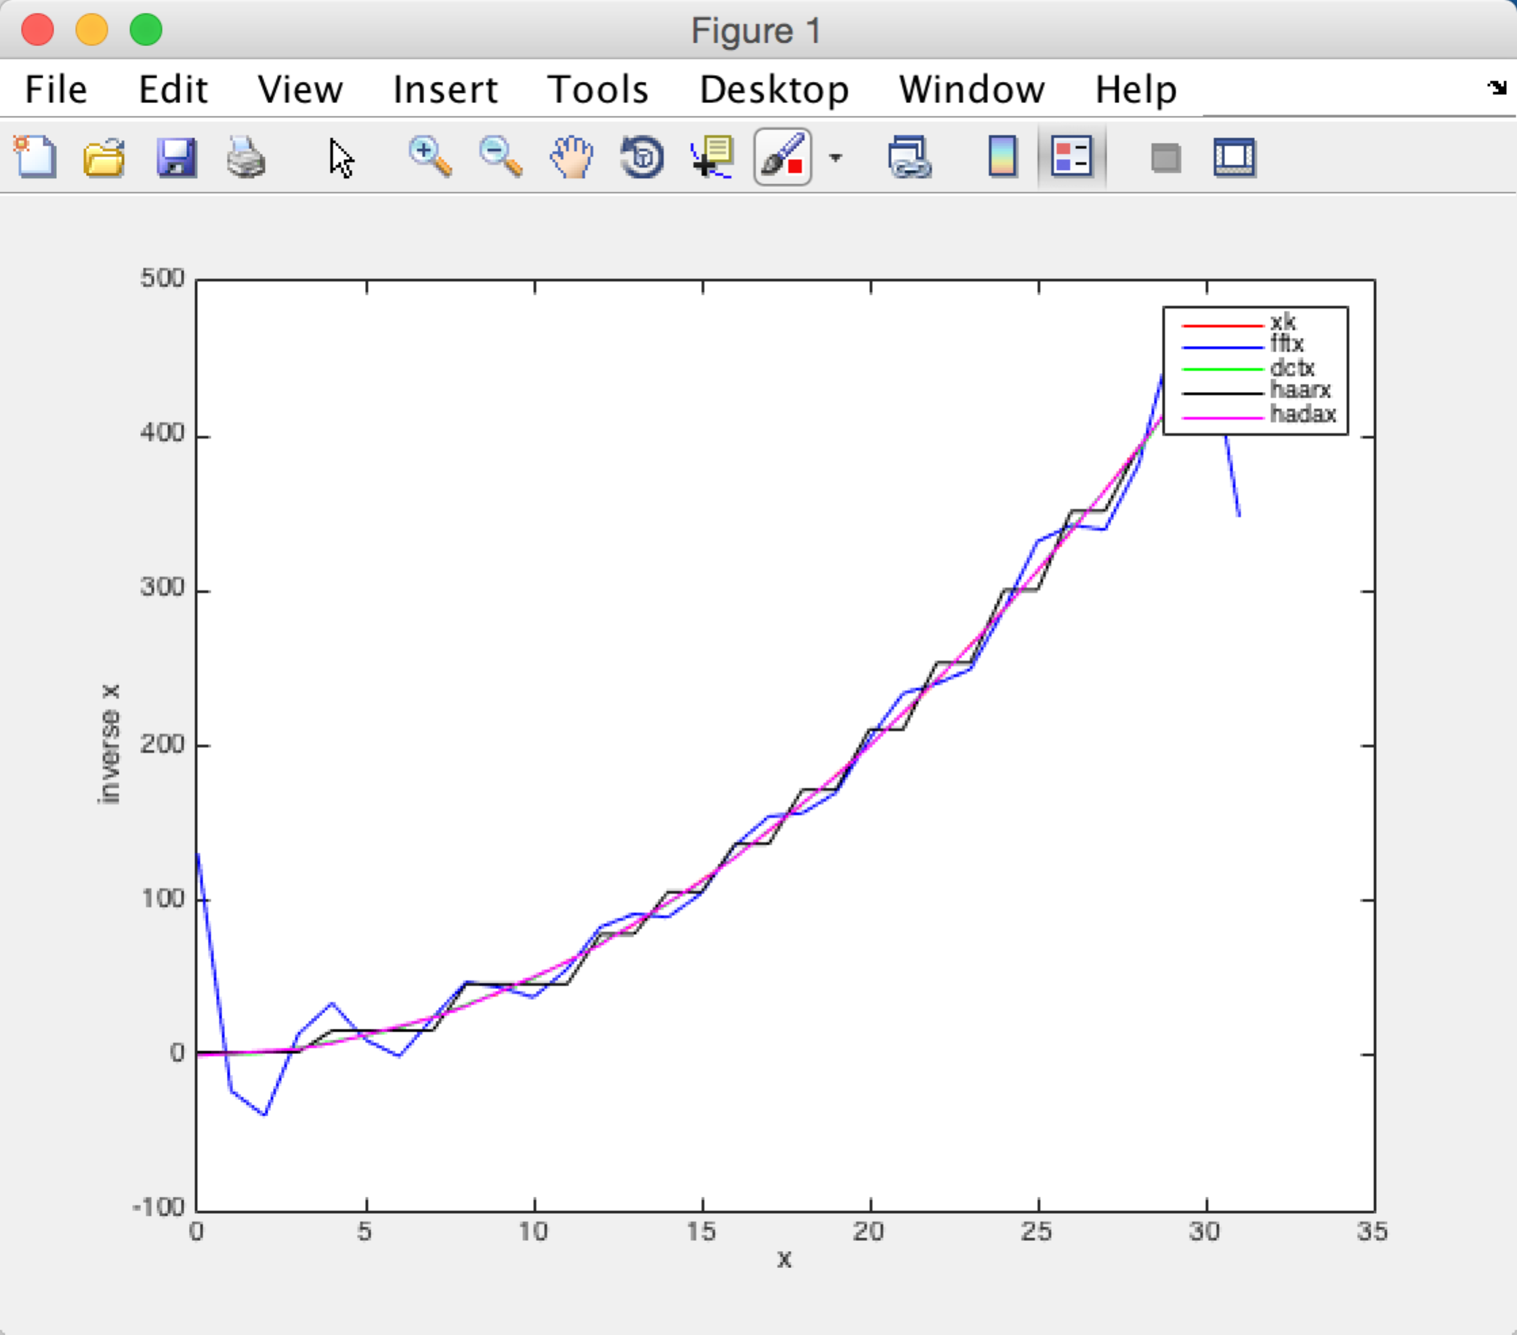

For y and all four inverse y, the code is :

clear

k = [0:1:31]

yk = sin((5\*k+1)\*pi/32)

Y = fft(yk')

MY = abs(Y)

TRY2 = sortrows(Y)

MY17 = TRY2(1:17)

YY = Y

for i = 1:length(YY)

if(ismember(YY(i),MY17))

YY(i) = 0

end

end

ffty = ifft(YY)

Y = dct(yk')

YY = Y

YY(16:length(YY)) = 0

dcty = idct(YY)

Y = haarmtx(32)\*yk'

MY = abs(Y)

TRY2 = sortrows(MY)

MY17 = TRY2(1:17)

YY = Y

for i = 1:length(YY)

if(ismember(abs(YY(i)),MY17))

YY(i) = 0

end

end

haary = inv(haarmtx(32))\*(YY)

Y = hadamard(32)\*yk'

MY = abs(Y)

TRY2 = sortrows(MY)

MY17 = TRY2(1:17)

YY = Y

for i = 1:length(YY)

if(ismember(abs(YY(i)),MY17))

YY(i) = 0

end

end

haday = inv(hadamard(32))\*(YY)

plot(k,yk,'r',k,ffty,'b',k,dcty,'g',k,haary,'k',k,haday,'m')

legend('yk','ffty','dcty','haary','haday')

xlabel('y')

ylabel('inverse y')

the figure is :  
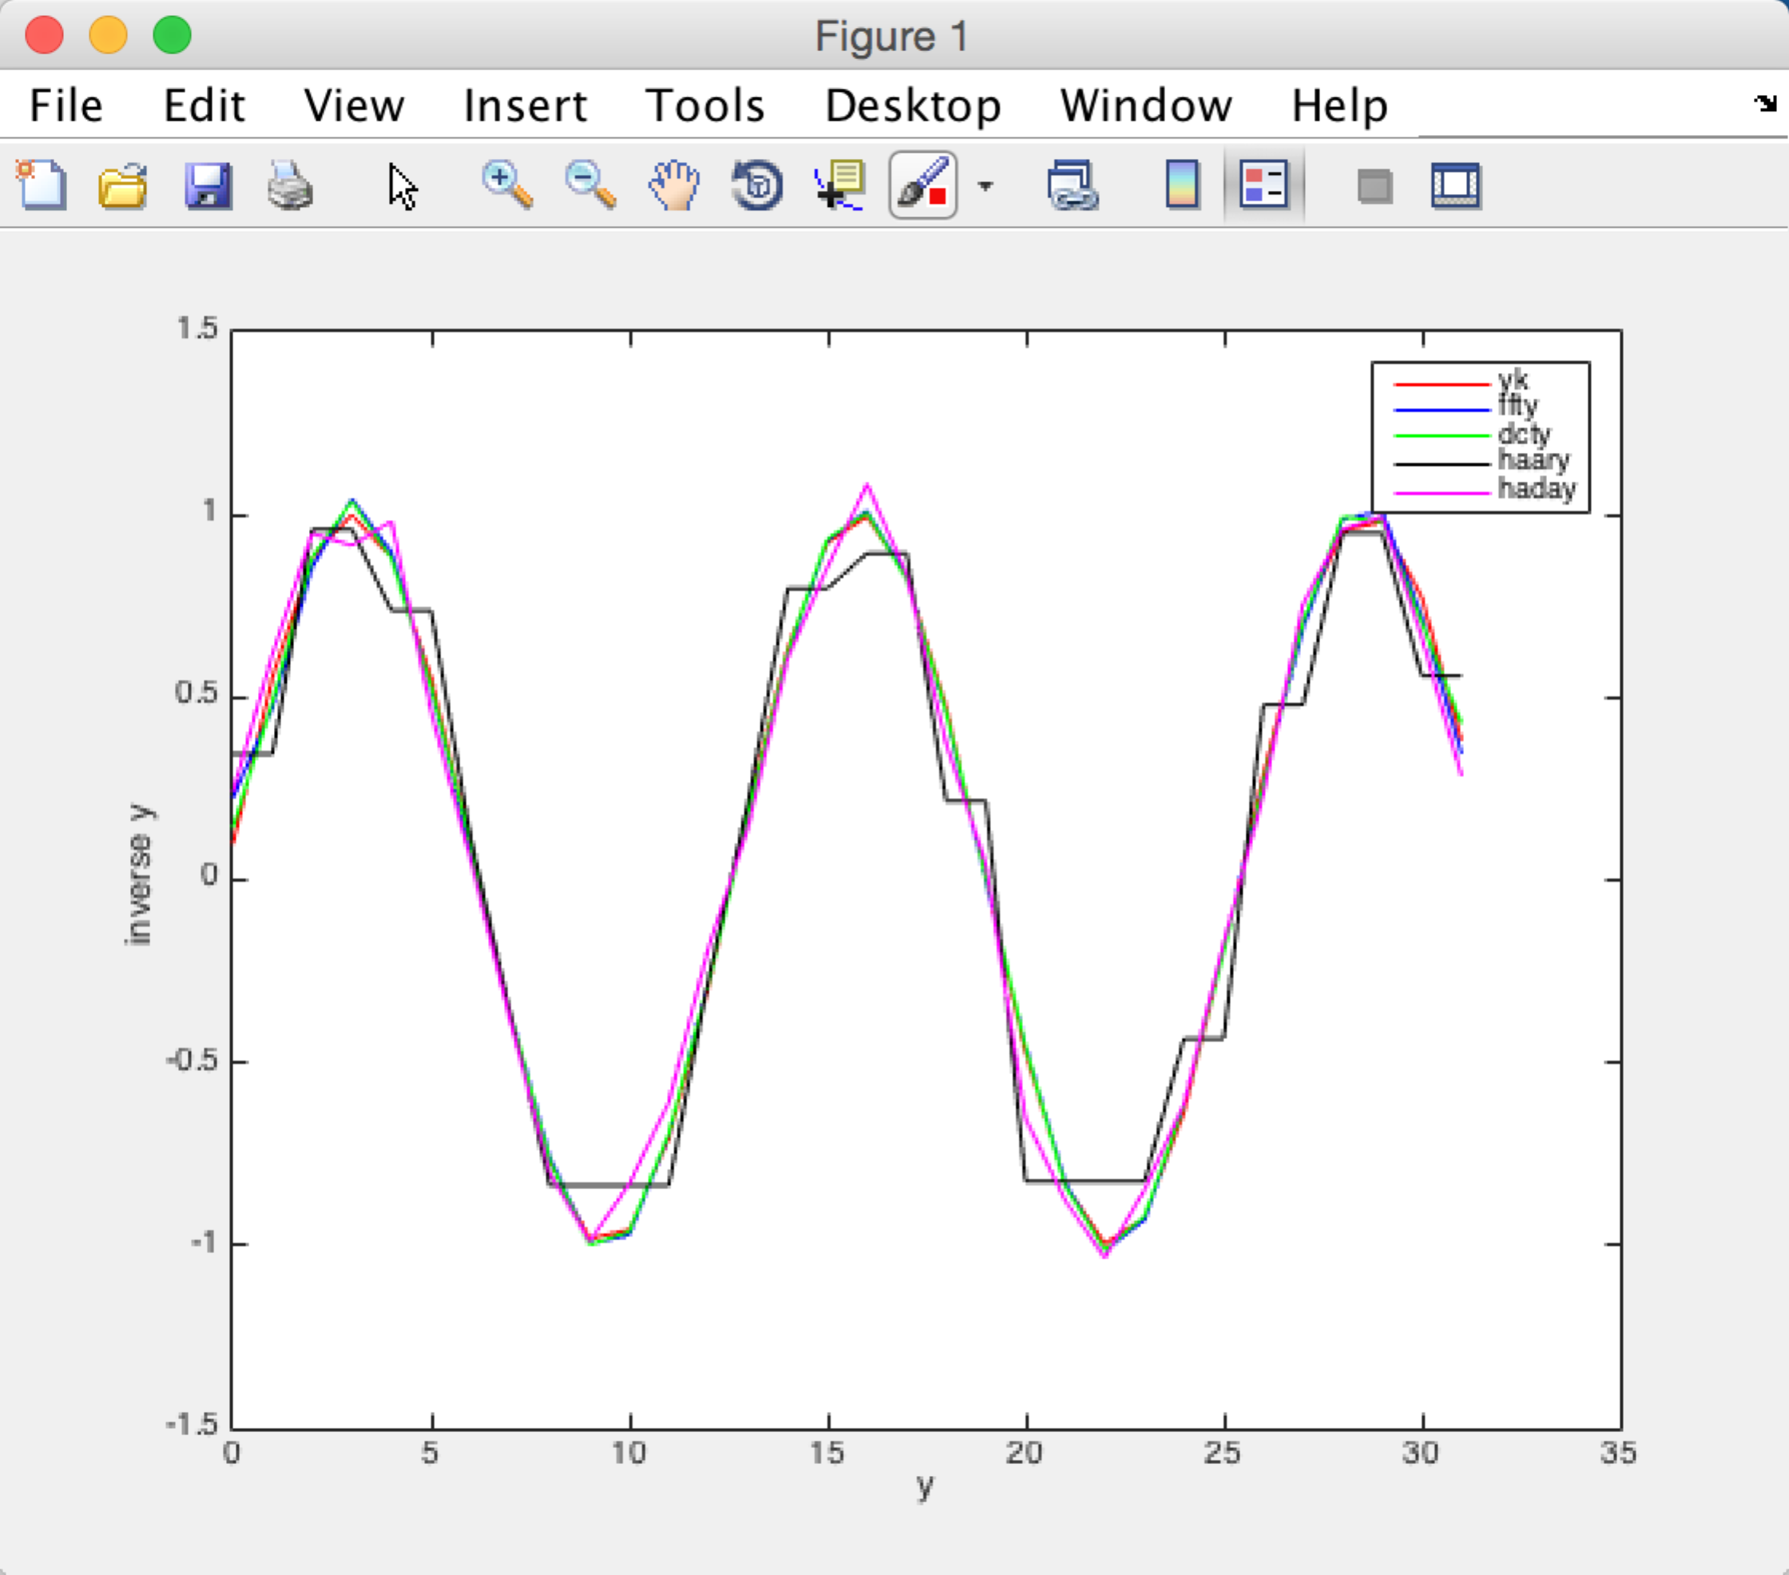

b.

MSE FOR X:

CODE:

fftxmse = mean((xk'-fftx).^2)

dctxmse = mean((xk'-dctx).^2)

haarxmse = mean((xk'-haarx).^2)

hadaxmse = mean((xk'-hadax).^2)

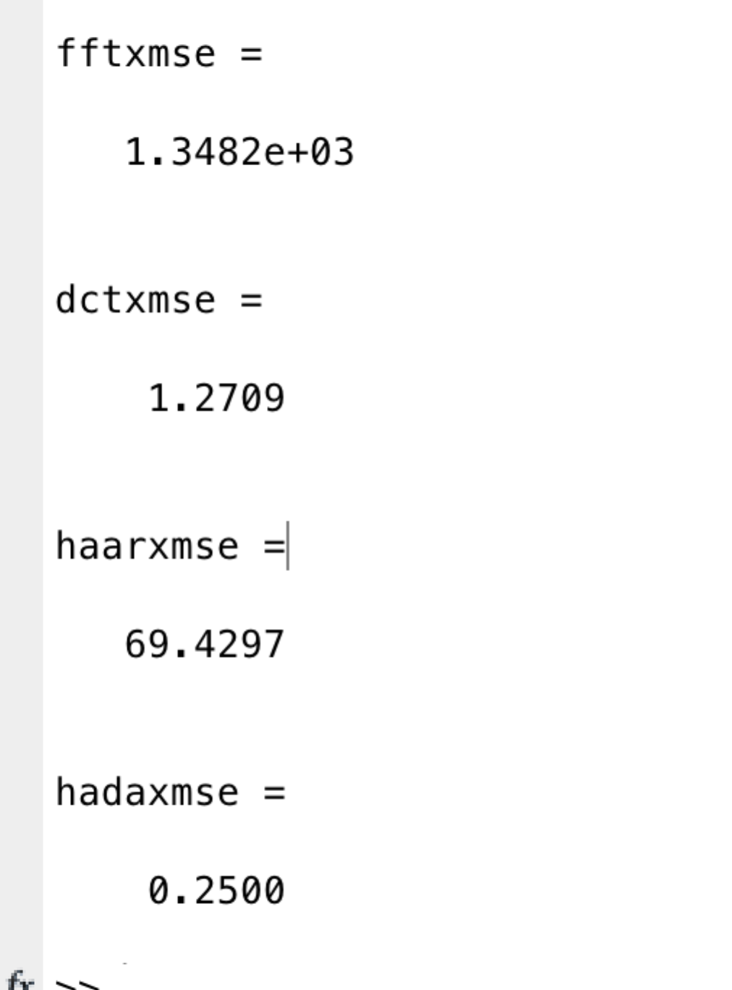

MSE FOR Y

CODE:

fftymse = mean((yk'-ffty).^2)

dctymse = mean((yk'-dcty).^2)

haarymse = mean((yk'-haary).^2)

hadaymse = mean((yk'-haday).^2)

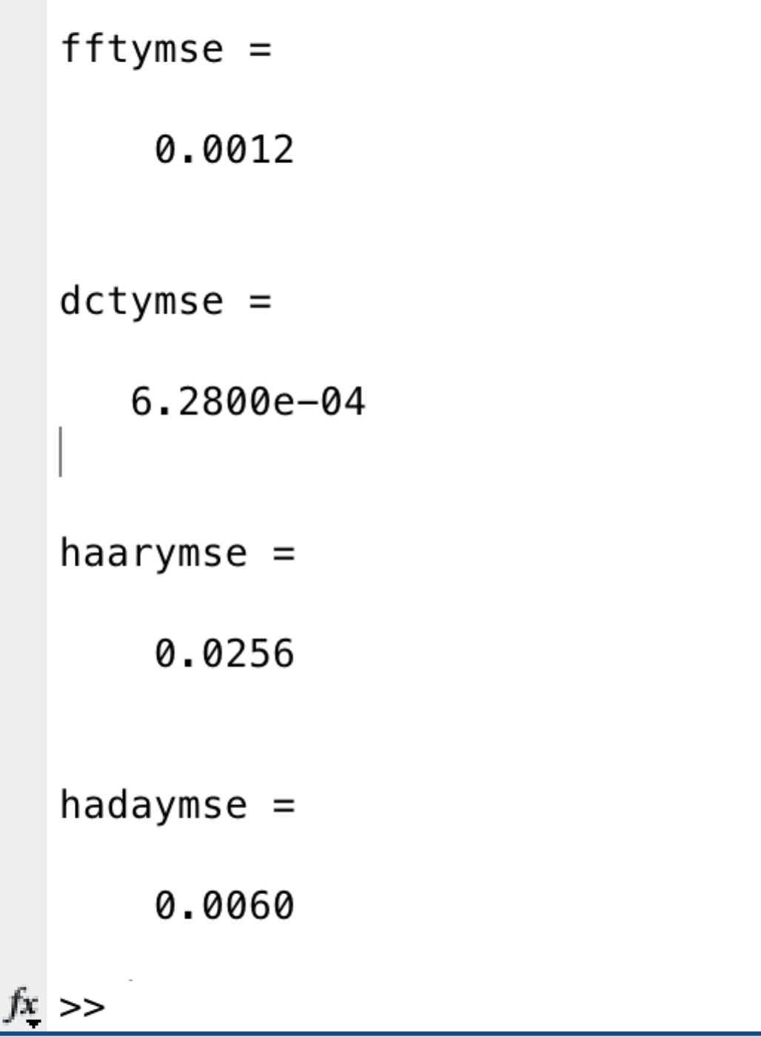

c.

The best reconstruction for X is Walsh-Hadamard transform. Because the hadaxmse = 0.25 is the smallest

The best reconstruction for Y is DCT transform. Because the MSE of it is the minimum.

d.

I have answered the question d for y in question a,b and c